**Fundamentals of Git & GitHub**



Git is a version control system for tracking changes in computer files. It was initially created in 2005 by Linus Torvalds who was also the creator of Linux. Some of the most well-known usages of “git” can be given as follows:

* Distributed version control (DVC)
* Coordinates work between multiple developers
* Who made what changes and when?
* Revert back at any time
* Local & Remote repositories

There's no specific language or framework or anything that you need to use git. You can use it for static HTML web sites, NodeJS, APPs, Python, Java, C#, etc. It is more like a “Distributed Version Control System (DVCS)” or “Decentralized Version Control System”. It means is that many developers can work on a single project without having to be on the same network. Every developer has complete codebase with full version history on their local machines (hard drive) stored. This is named as “local repository” and it is not visible to other developers until it is uploaded to the server which is named as “remote repository”.

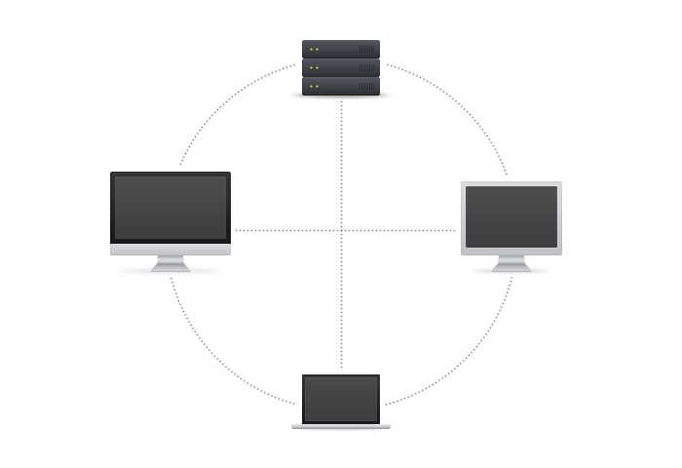

There's also “Central Version Control System (CVCS)” that developers actually need to be on the same network to use. You can also revert back to specific versions of any file at any time as long as it was committed to the repository.

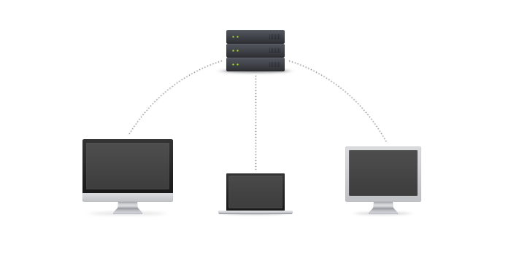

Usually, when you use git, you'll have a repository on your local machine that you work on. You don't need an internet connection to work on a local repository but if you want to “push” it to the remote repository, you will need an internet connection. After a successful uploading (push) progress, your changes will be visible to others as well.

Before we move on further, I would like to give some basic words that we use within the “git” ecosystem. Here is a list with short definitions:

**Git Terminology**

* **Repository:** Repository is a central location in which data is stored and managed.
* **Commit:** Commit is an operation which saves the changes permanently.
* **Staging Area:** Staging is a step before the commit process in git. That is, a commit in git is performed in two steps: **staging** and actual **commit**.
* **Push:** The **git push** command is used to upload local repository content to a remote repository.
* **Pull:** The **git pull** command is used to fetch and download content from a remote repository and immediately update the local repository to match that content.
* **Remote Server:** Remote server is a server which is not on a LAN (Local Area Network), it serves the data to the users across the globe.
* **Branch:**The branch is like the directory of your project which contains all the files in it. Git repository always creates the default branch which is called master branch.
* **Clone:**Clone is the process of creating copy of something.

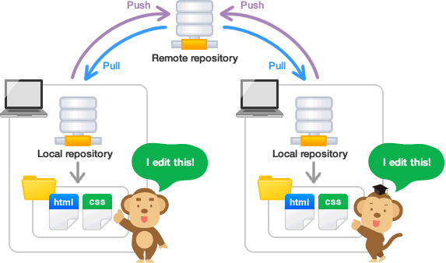

One of the most important function of git is to keep track of your code versions. It essentially keeps track of your code history with snapshots of your files. We make these snapshots by making a “commit” with a simple command. You can always go back to see any snapshot of previously written code. You can always revert back if you need to. Your code is extremely safe when you're working with git. You can put your code in a staging area before actually doing the commit and writing to the snapshot. This is done with a simple “add” command. We’ll go over all these important commands with practicals. Once you make a commit to a remote repository, other developers can then “pull” that information onto their machines. We can also create branches for every new commit. The following diagrams show the relation between the different sections of Git workflow while its operating between the local and the remote repositories.

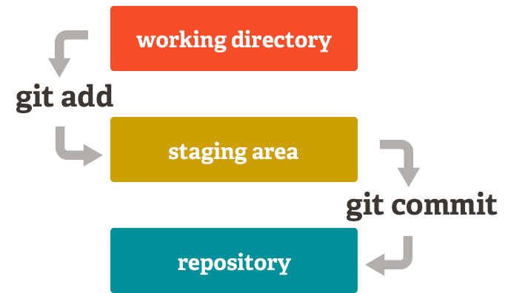

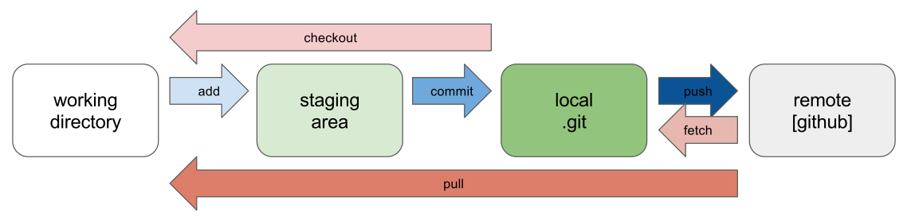

**Installing Git**

Before you start using Git, it’s probably a good idea to update to the latest version. You can either install it as a package or via another installer or download the source code and compile it yourself.

* If you are using a Debian-based Linux distribution, such as Ubuntu, use the following command:

*sudo apt install git-all*

* If you are working on a macOS system, there are several ways to install Git. The easiest way is to probably to install the XCode command Line Tools. If you have installed Homebrew to manage packages on macOS, then simply execute:

*brew install git*

command from the terminal.

The other way to install Git is by downloading the mac version of installation package from the following page:

<http://git-scm.com/download/mac>

* Windows Git installation only requires downloading the installation package and follow the instructions. You can follow the link to download the installation package for Windows.

<http://git-scm.com/download/win>

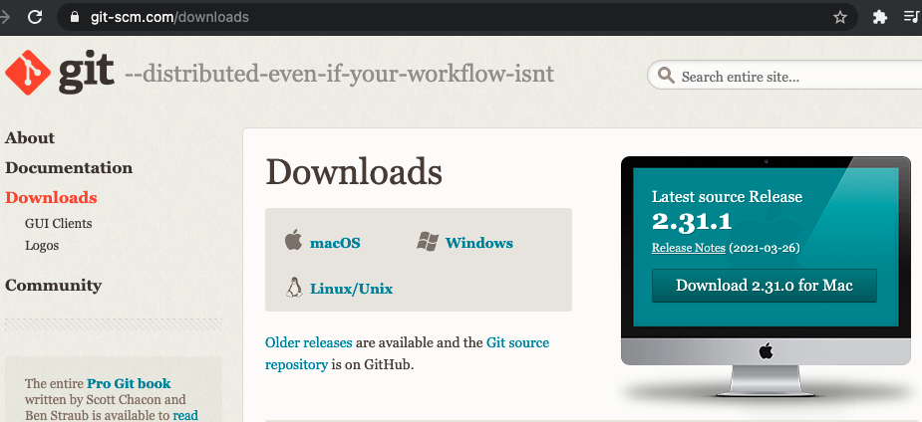

**First-Time Git Settings**

Now we need to do a few things to customize our Git environment. These steps are required only once on any computer and they will be kept even after some version upgrades done. Of course, they are also possible to be changed with the same commands again.

The first command to run is the “*git config*” command. This command lets you set the configuration variables of how Git looks and operates. This command sets some of the configurations like the name, email, id, etc. We can set the username by the following command line:

*$ git config --global user.name ‘youngCoder’*

Secondly, we need to establish the user email address that the Git account is registered to. It is similar with the previous username setting command.

*$ git config --global user.email ‘*[*kasim.gul@youngcoders.nl*](mailto:kasim.gul@youngcoders.nl)*’*

Those command settings need to be done only once, unless you need to change them. If you want to override these information with another name or email for specific projects, you should run the “git config” command without the “--global” option.

**Choosing your Git Editor**

When we need to type in a message, if not configured the Git uses the default system text editor. Let’s say we want to use the “atom” as our default Git editor, then we can set it with the following command line:

*$git config --global core.editor atom*

If you prefer “vi” or “nano” as your text editor, then you should change “atom” with “vi” or “nano” in command. I am going to use the “atom” which is one of the most preferred code and text editor IDE.

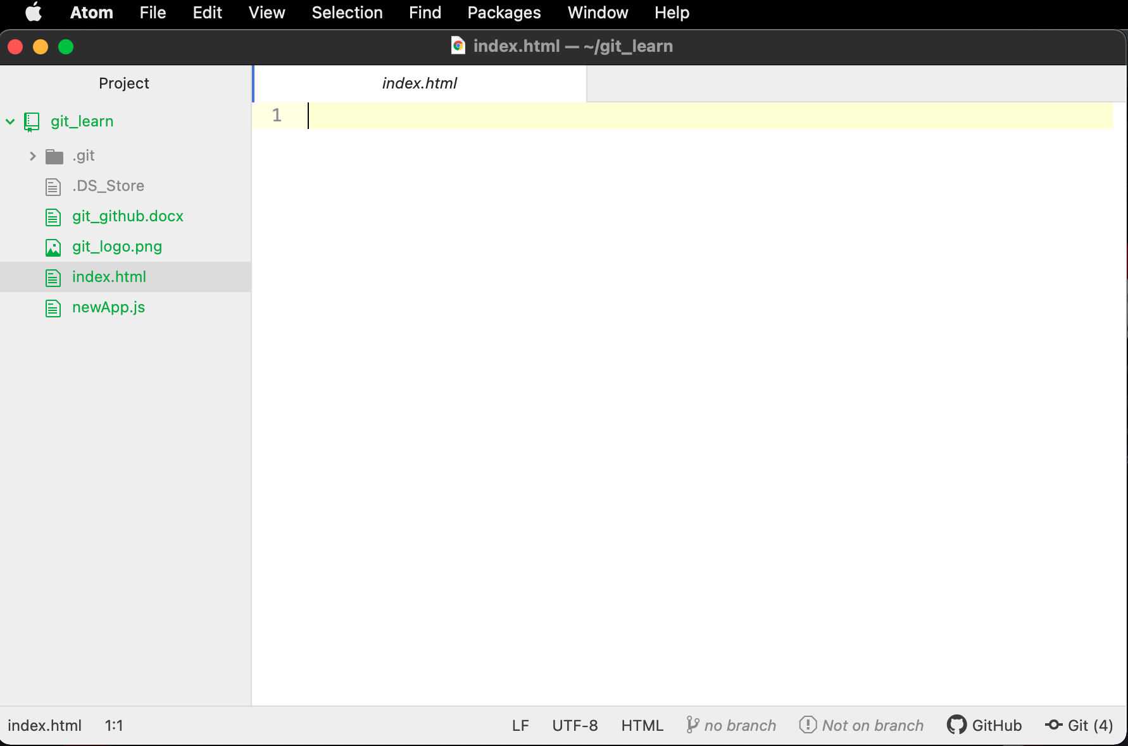

**Getting to Git Commands**

There are many “git” commands, but some commands are used most frequently. We will go through with the 10 most used commands. Now let’s look at those repository management commands.

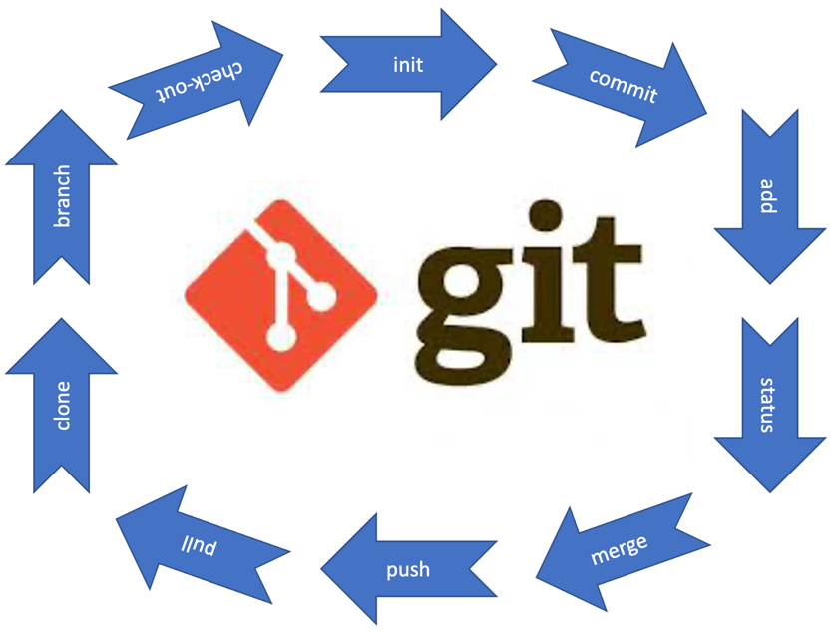

1. **get init:** This command initializes a blank git repository and creates a “.git” folder in the current working directory. If you create or go into an existing folder and execute the “get init” command, it will create a “.git” folder in that present folder and it's hidden by default. Once you initialize that folder as a repository, you can then start to run other commands.

Before using the “git init” command, I’ll create a new folder called “git_learn” under my user directory. You can create your new folder with any name within your desired directory of the local drive. I’ll use the terminal to do it, but you can create your folder with any other possible way.

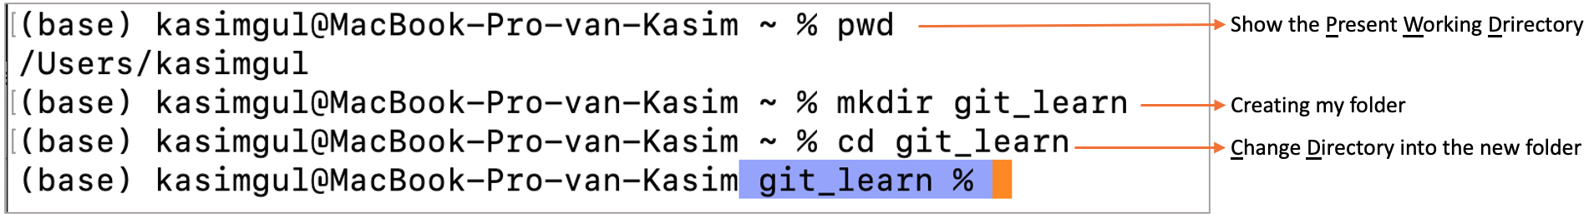

This is an empty directory when first created. I’ve copied a few files into this new folder. Your selected files and folders might be different than my files. I could use only the “ls” command to list present files and folders, but I added “-al” options to list the hidden files “-a” and also show their properties with details “-l”.

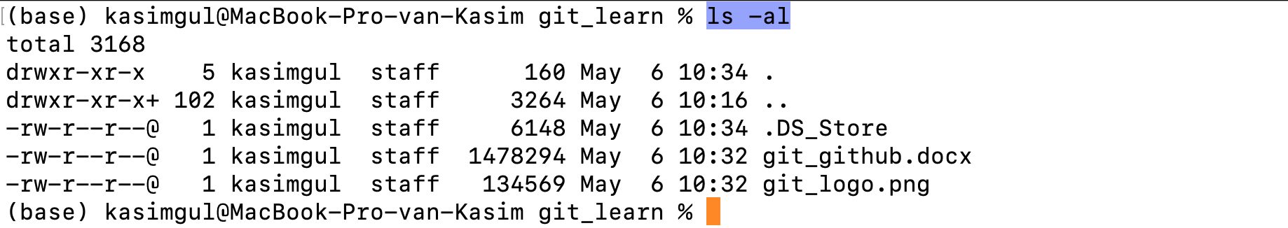

Now we are ready to execute the “git init” command within this folder. Actually, we could even do the “git init” command before copying those files or folders into our new “git_learn” directory but I just wanted to include them at first, since we are going to need them for practical purposes. You can also create a few new files by using text editors or some other commands such as “touch”.

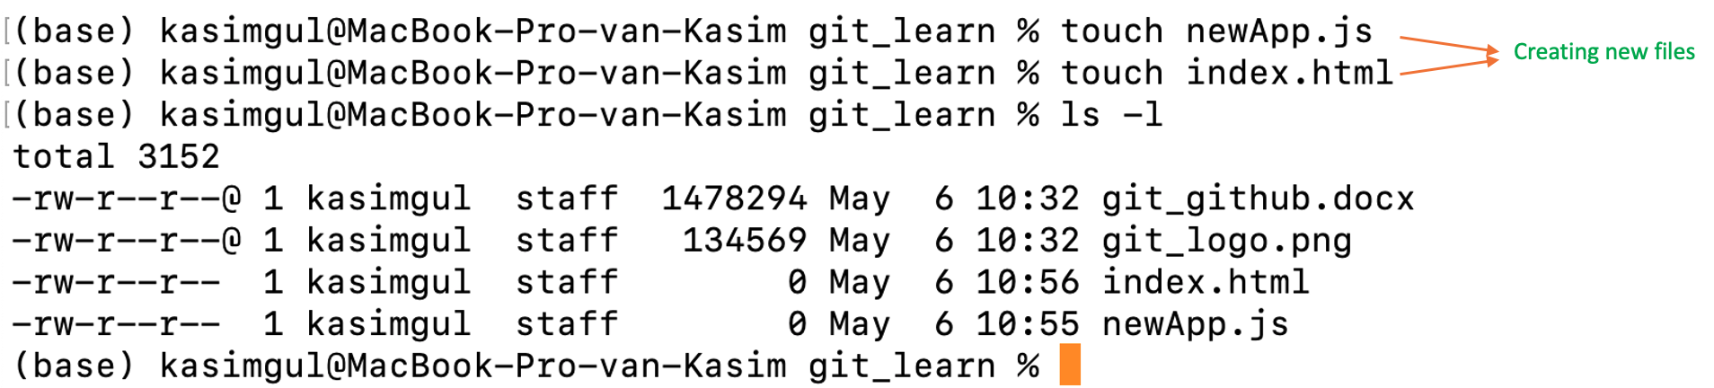

Let’s follow up with the “git init” command.

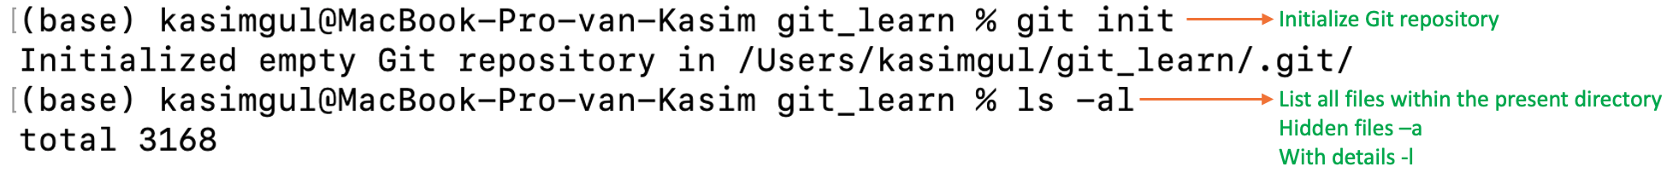

You should remember to use “-a” option to see the “.git” repository folder because it is hidden when created as default. You might use a different way to show it on Windows file manager.

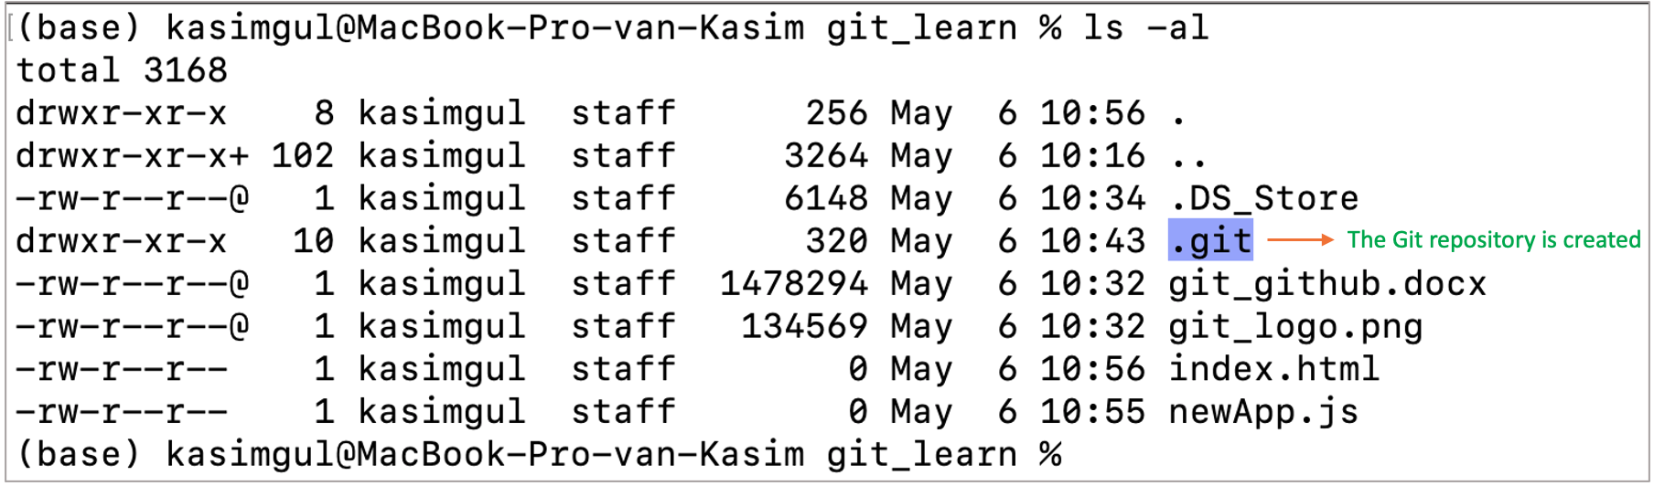

As you see that we have the “.git” “local repository” created. We can move into by “cd .git” command and list of all created files and folders.

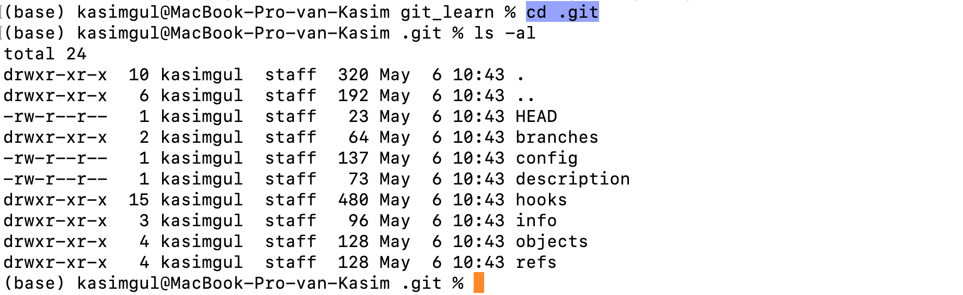

1. **git status:** This command is used to display the state of the current repository and the staging area. It lets us to see which changes have been staged, which haven’t been staged and which files aren’t being tracked yet. This command simply shows what is happening with “git add” and “git commit”. The status messages include relevant instructions for staging and unstaging the files.

SCREEN SHOT

We can see that “git status” first shows some “untracked” files and after “git add” command is executed, the “git status” command shows the status of the files as there are no commits yet. The file name that was initially “red” in color becomes “green” now.

1. **git add:** This is the command where we start adding any file from the “working directory” to the “staging area”. Let’s say we want to add “index.html” file to the staging area.

*$git add index.html*

There will be no visible output after the code executed. We should use

$git status

command to show the files in the working directory and in the staging area. If a file is new created or an existing file modified, they will be listed as red color. After executing the “git add <filename>” command, and then run the “git status”, those files will be listed in green color. This means they are added to the staging area successfully. However, at our first run of “git status” command, there will be no files listed.

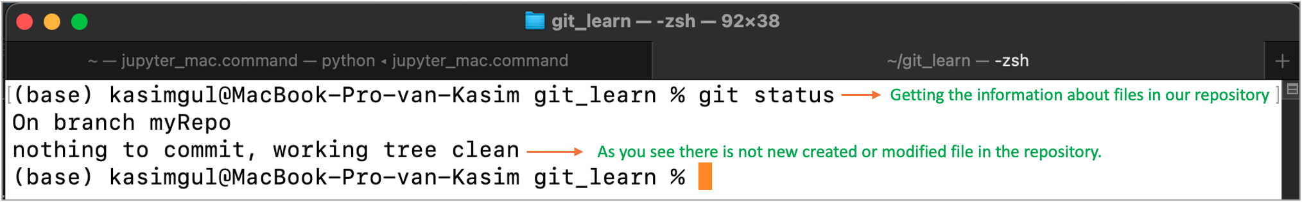

Let’s edit the index.html file and save the file. It means the file is being “modified”. I only edited the “title” and included a sentence in the “body” as follows:

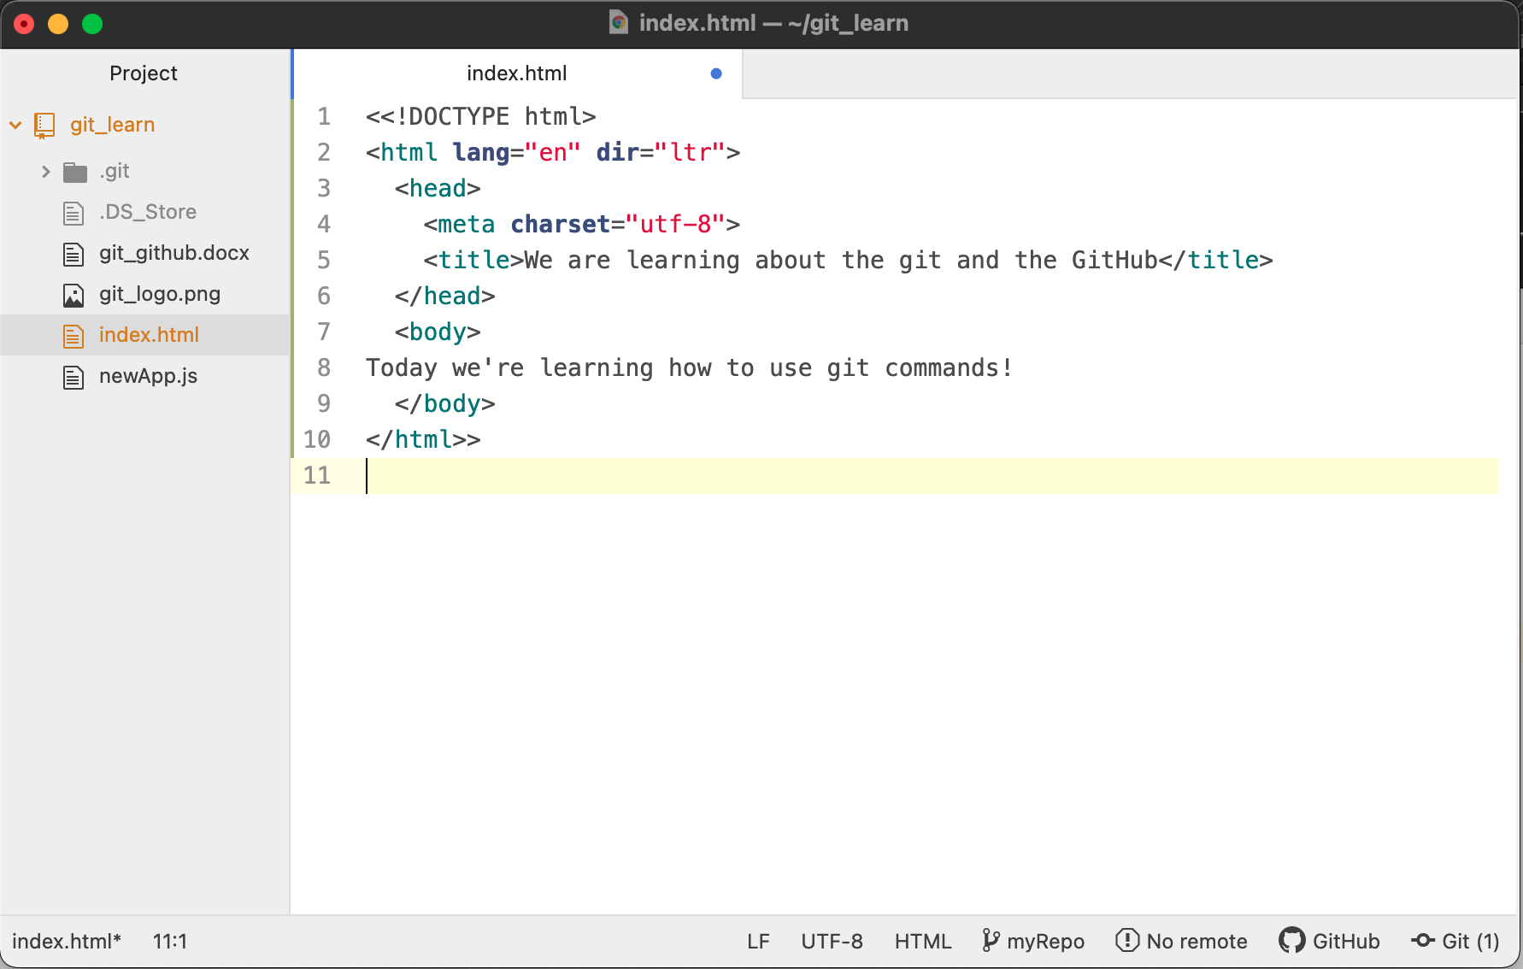

This time the “git status” command will list the index.html file as in red color. This means that the index.html file is modified or newly created and still within the working directory.

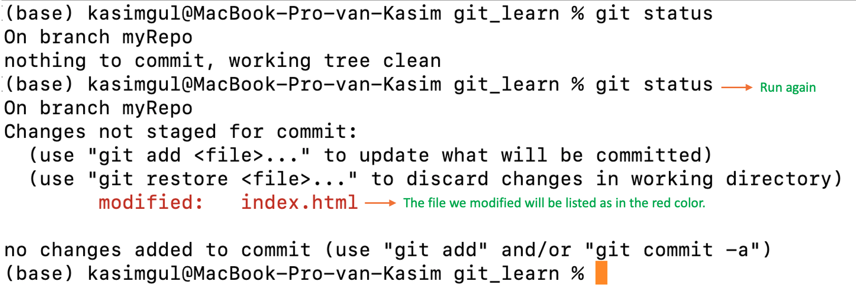

As you’ll remember, we need to “add” the file first to “staging area”. To do that we run the

$*git add index.html*

command. There will not be any visible output. Let’s run the “git status” command again.

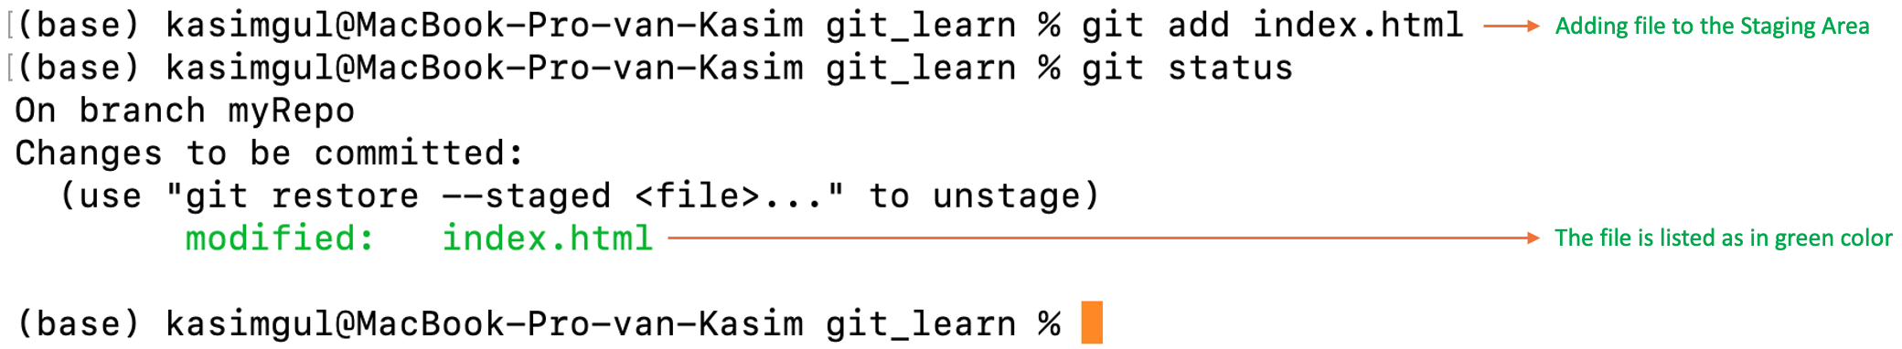

What if we don’t want to go further with the index.html file and remove it from the staging area? Then we can use the following command to take it back to the working directory:

*$git rm --cached index.html*

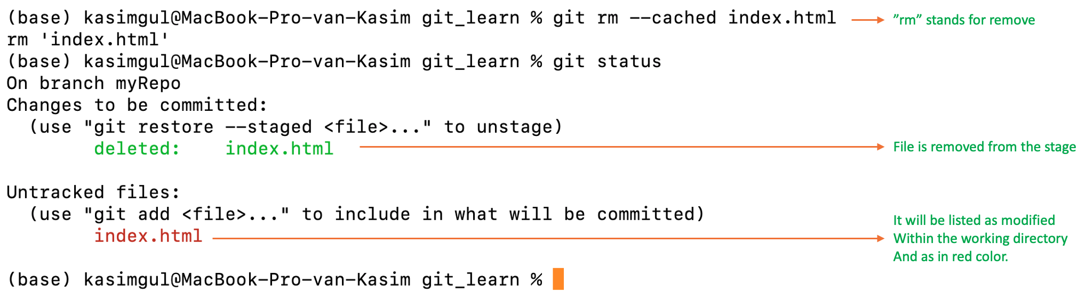

I would like to show a few more options to “add” files into staging area. Let’s say we want to add all files with “.html” extension at once to the staging area. We can use the following command for it:

*$git add *.html*

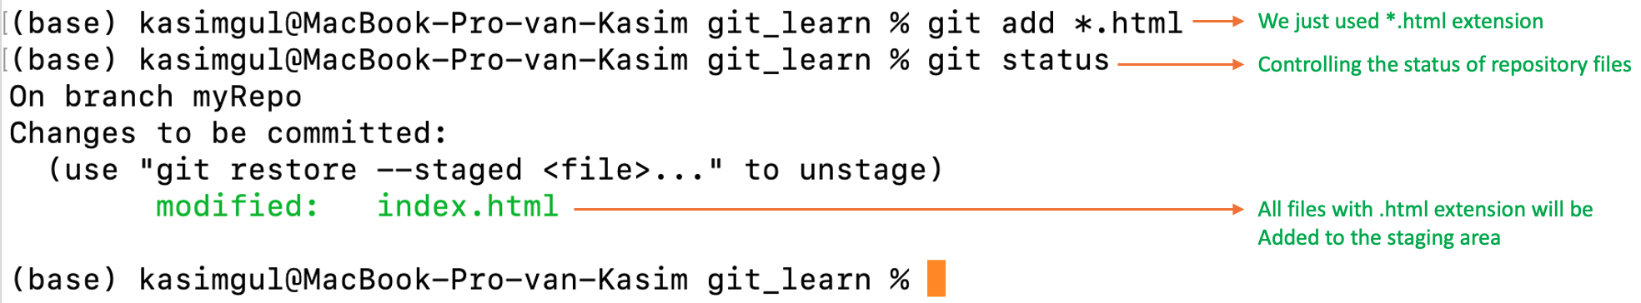

Let’s remove the index.html file back to working directory and try another way. This time we’ll add all files from the working directory to the staging area together. First, I also want to modify “newApp.js” file. So, we’ll have two files as modified and can be added together to the staging area.

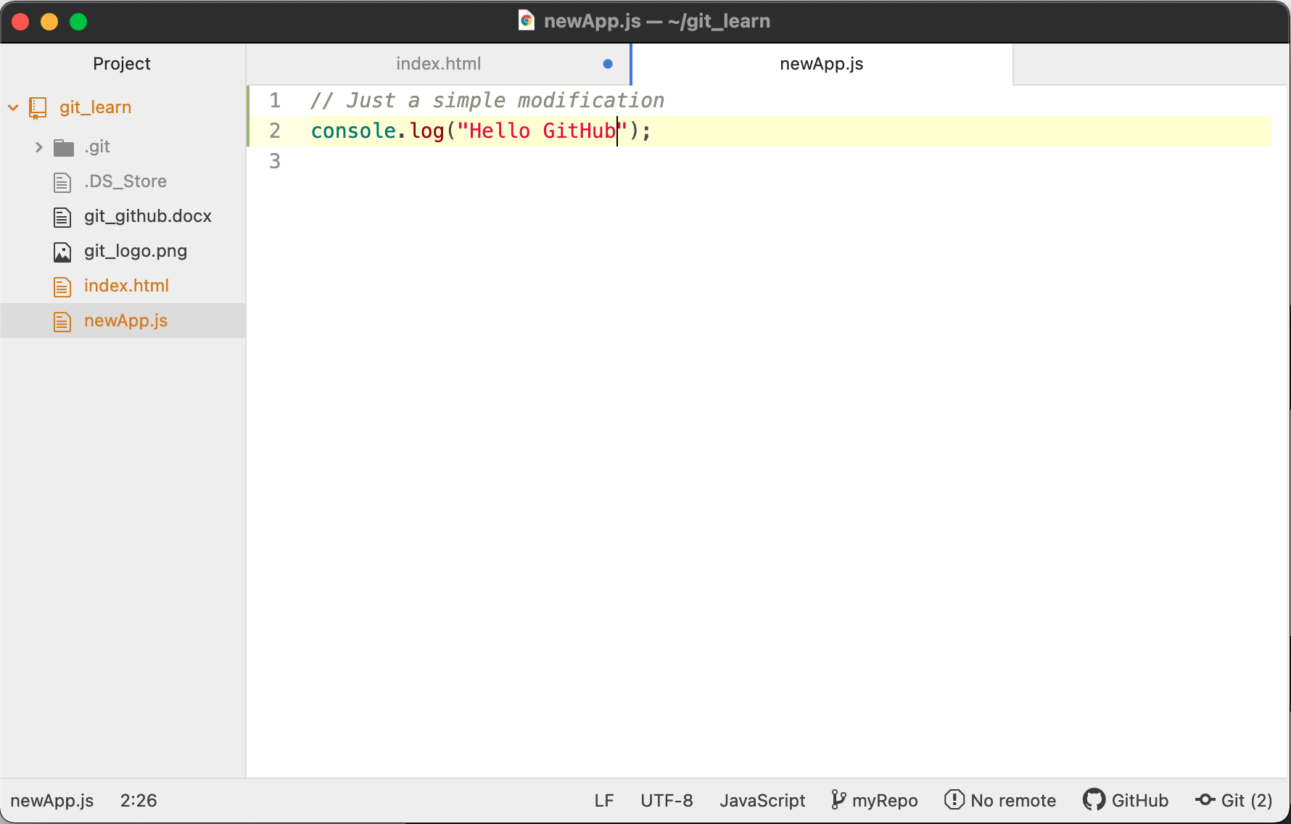

After we edit the newApp.js file and save the changes, now we can execute “git status” command to see the list of files within the working directory.

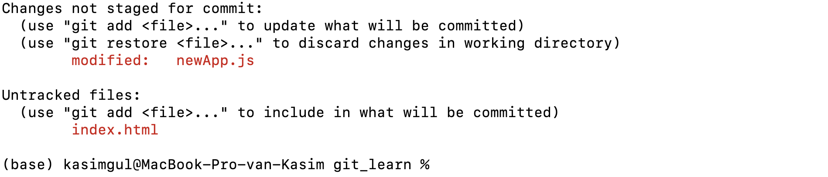

To add all files to the staging area at once, we can run the following command:\

*$git add .*

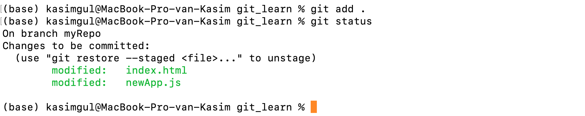

As you’ll see that both files are added to the staging area by using only a “.” and both files are listed as in the green color. Just keep in mind that any time you modify a file it will return back to the working directory and we need to use the “git add <filename>” command again.

1. **get commit:** Now we are ready to “commit” the changes in the repository. This command is used to save the changes to the local repository. Once we reach a certain point in development, this command helps us to keep record of all the changes. The changes that are made are the ones that are added to the “staging area” and it depends on us which files we want to commit. It is more like setting a checkpoint in the development process which you can go back later if needed.

We also need to write a short message to explain what we have developed or changed in the source code. This will help a lot to others to understand the reason of changes and the updates you’ve made in the code.

*“git commit -m ‘your commit message to others’*

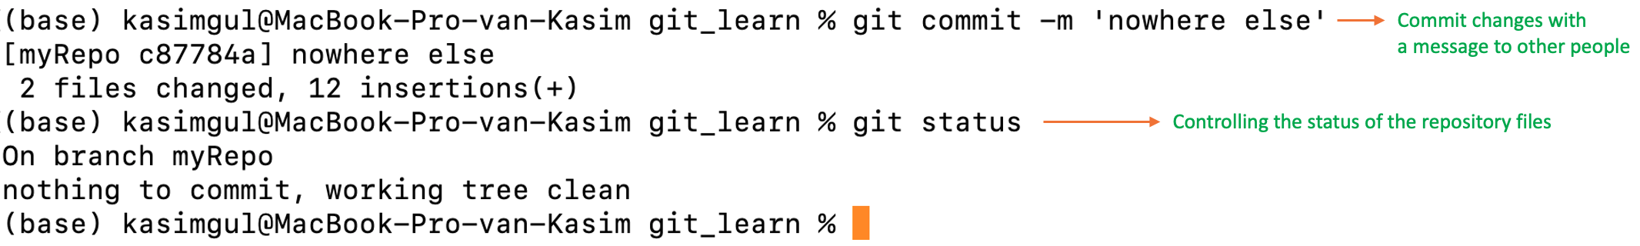

1. **gitignore file:** Sometimes we don’t need or want some files to be tracked and considered by the Git repository control system. Basically, we want to “ignore” those files. These might be automatically generated files such as log files or produced and used by the OS system in default. In these situations, we can create a file that lists the patterns to match those files to be ignored. Let’s create a simple “.gitignore” file and add a few possible file patterns to be ignored by Git.

*$touch .gitignore*

This command line creates a new file within the directory of our repository.

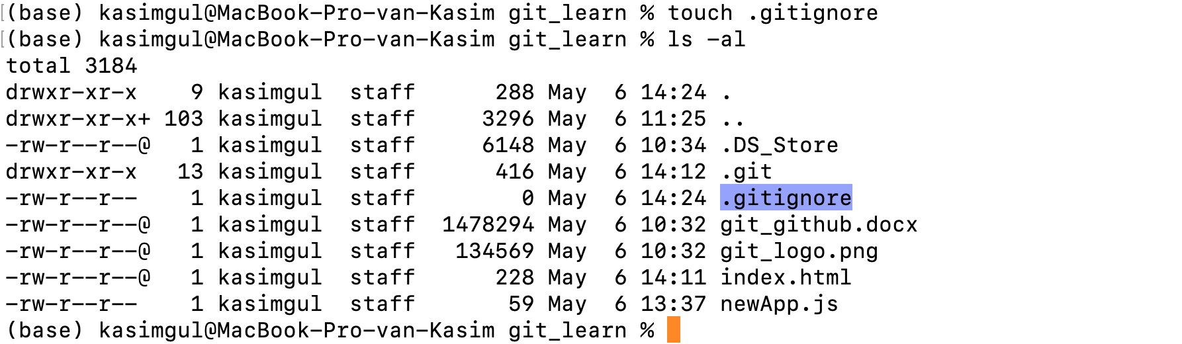

I’ll also create a generic “.log” file which is normally considered to be ignored by Git.

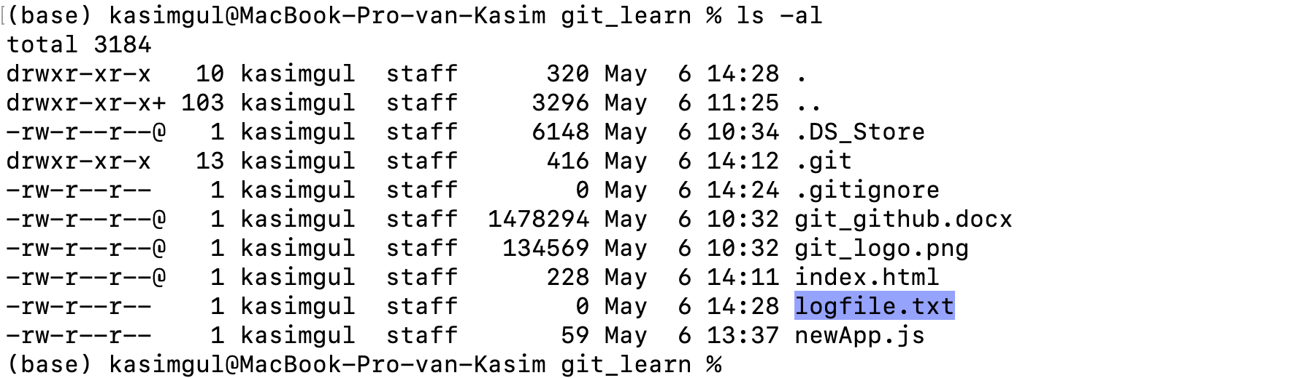

I’ll also edit the “logfile.txt” with a simple additional sentence.

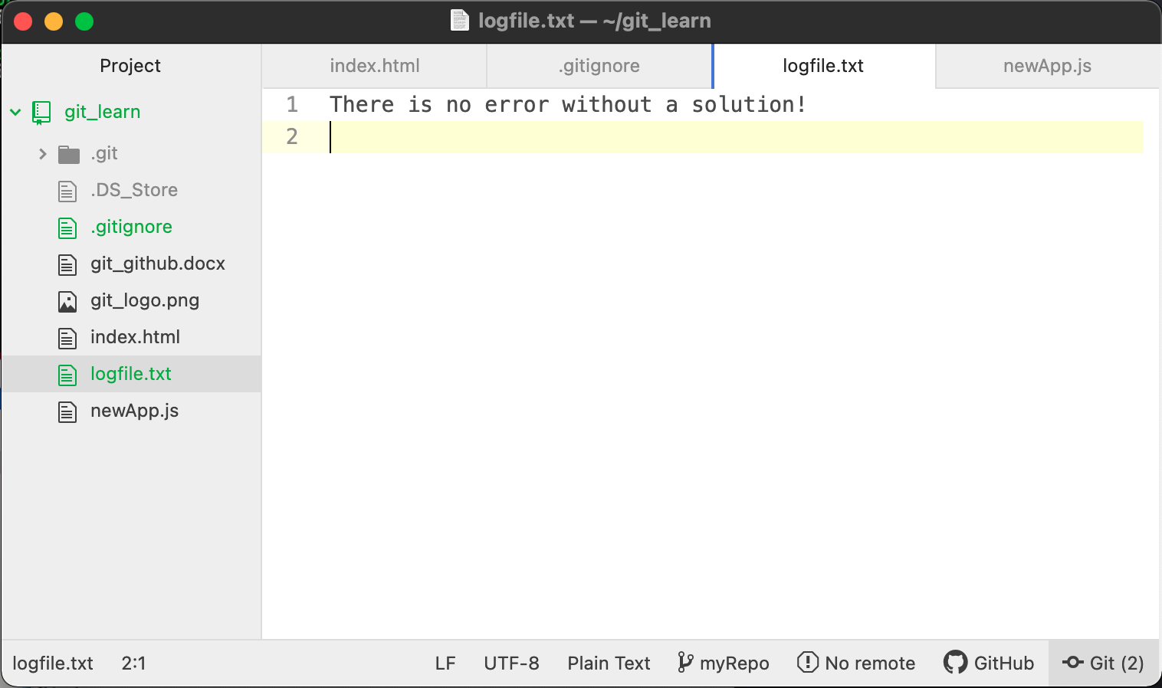

Now, we need to add this “logfile.txt” file into the “.gitignore” file. I’ll also do it in atom editor.

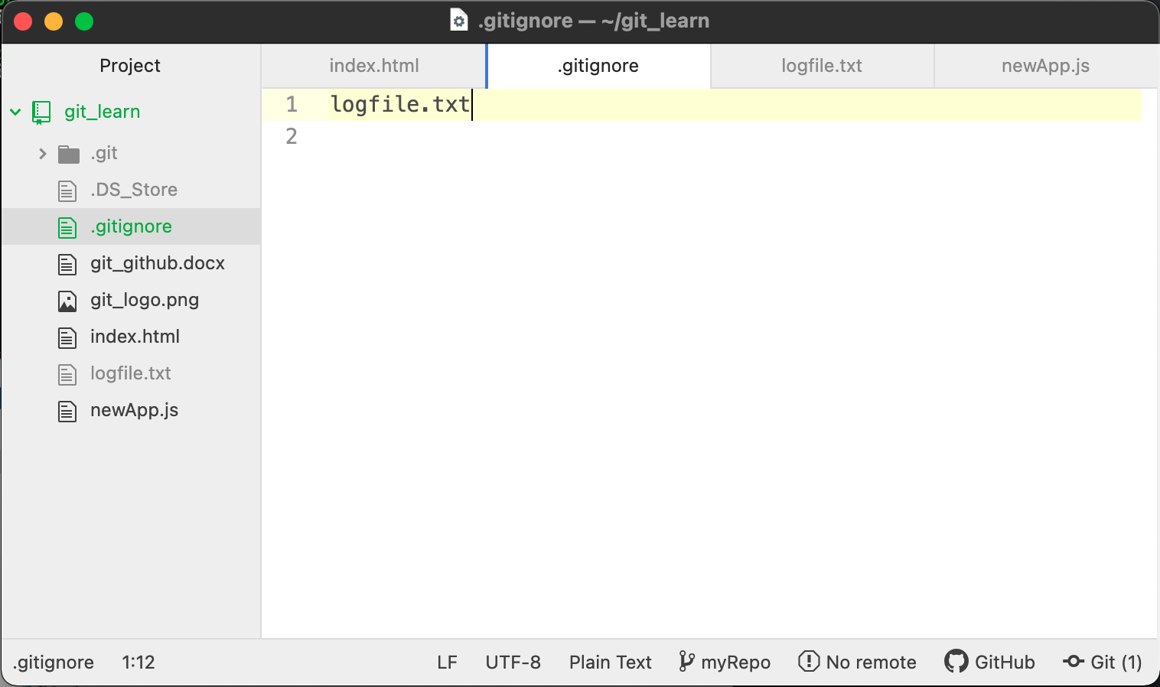

If we run the “git status” command, since we’ve changed 2 files, there should be 2 files listed.

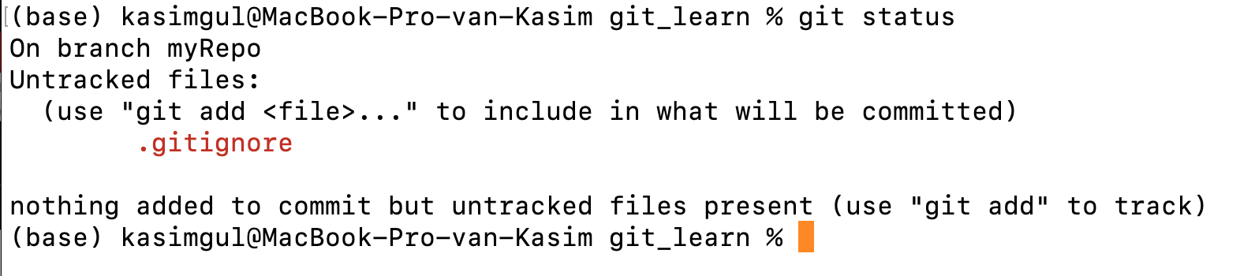

As you see that we get only one listed which is the “.gitignore” file. Because we’ve added the other file “logfile.txt” into “.gitignore”, so it will not be tracked and listed by Git.

Let’s say we want to ignore a folder completely with its contents as well. I’ll create a folder named “pics” and also include a picture inside that folder.

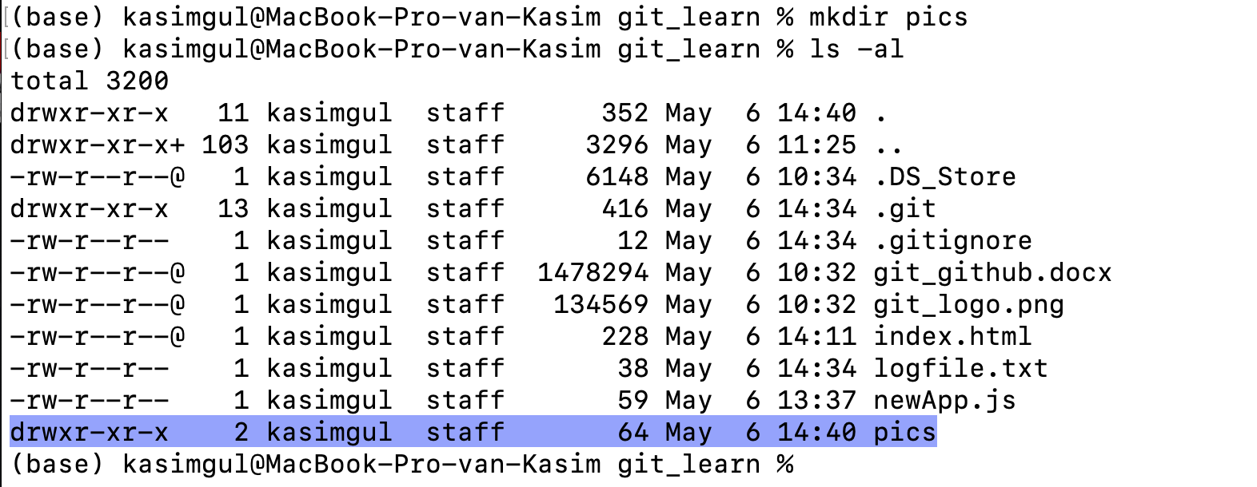

I’ll also copy the “git_logo.png” file into the new folder.

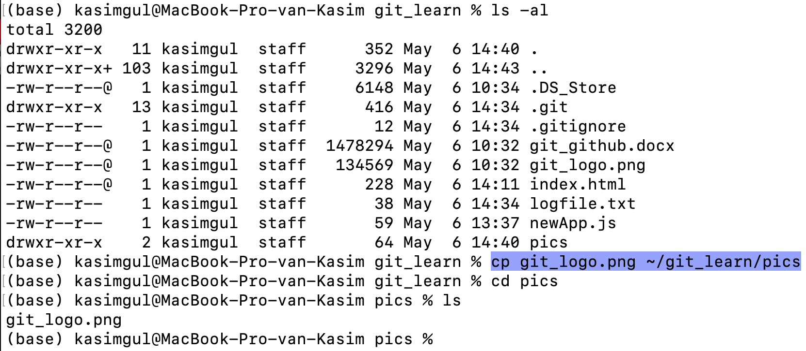

So, now let’s check the status of our repository by “bit status” command.

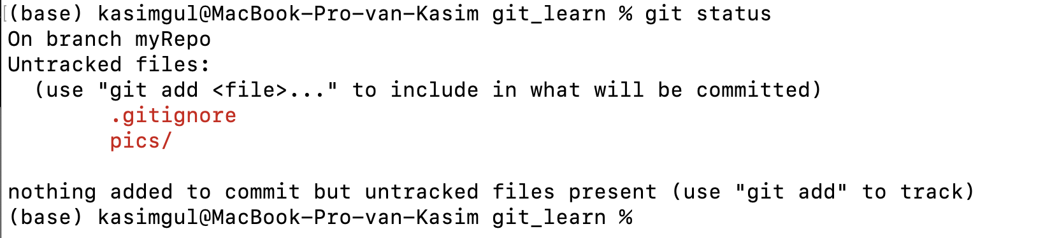

As you see we’ll get the “.gitignore” and the new folder listed. Now, I’ll add the new folder into “.gitignore” file and save it. So, I expect Git to ignore that folder after I run the “git status” command.

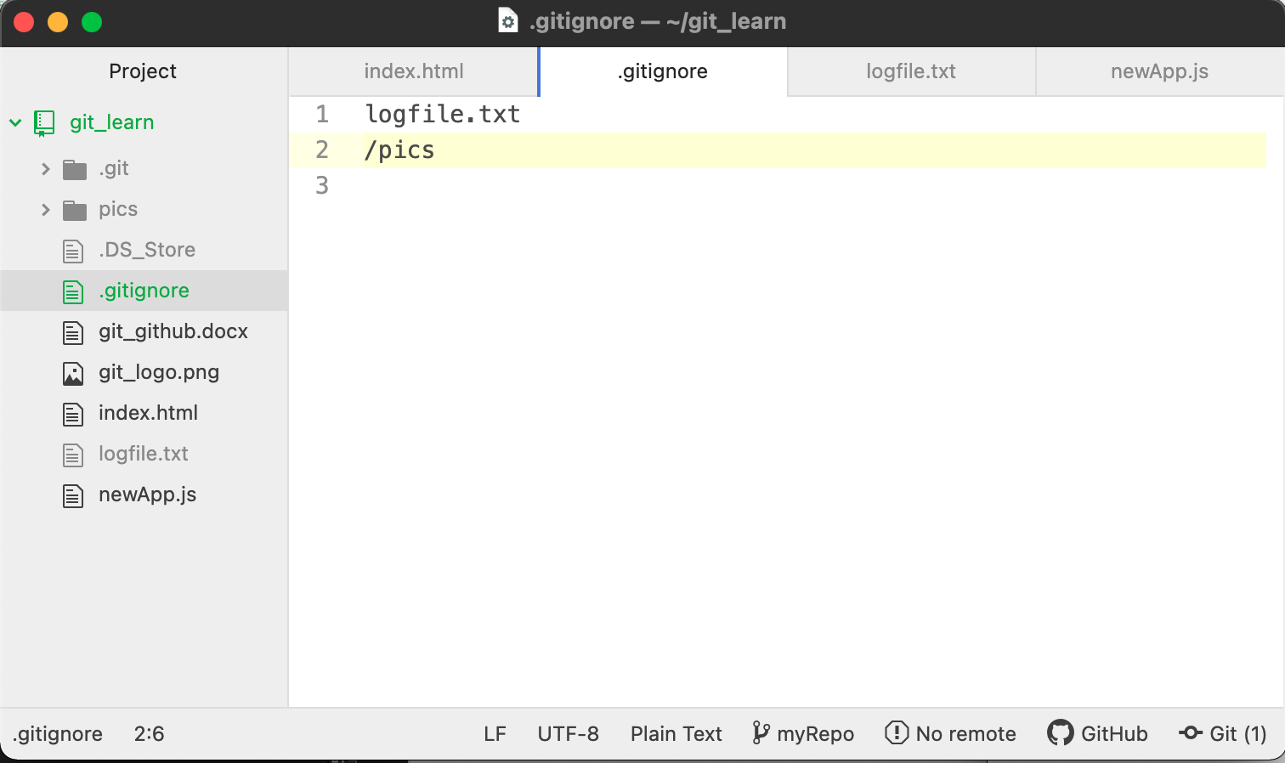

I’ve added the new directory name after a right slash symbol to specify it as a directory.

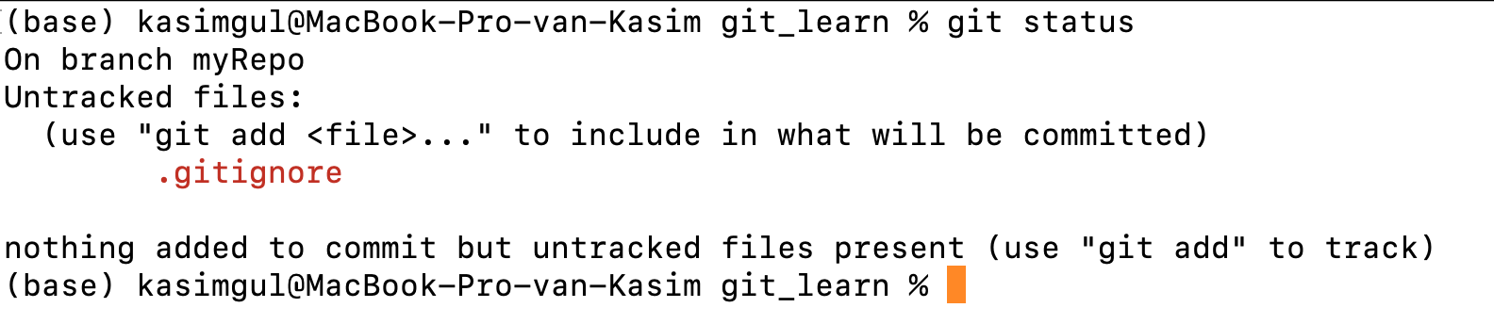

Now, the “git status “ command doesn’t list the “pics” folder which we’ve created including another file inside it. There are many other expressions that can be used as well such as “*.txt” will ignore all the files with “.txt” extension.

1. **Git Master/Main and new branches**

By default, Git will create a branch called “main”. For the repositories that are created before the date of October 2020, it was all named as “master”. From Git version 2.28 onwards, it is possible to set a different name for the initial branch. I’ve set the default branch name as “myRepo” by the following command line:

$ git config --global init.defaultBranch myRepo

Let’s show the Git config settings once more:

$git config --list

or in a shorter form:

$git config -l

This command will give us all the settings of Git at that point.

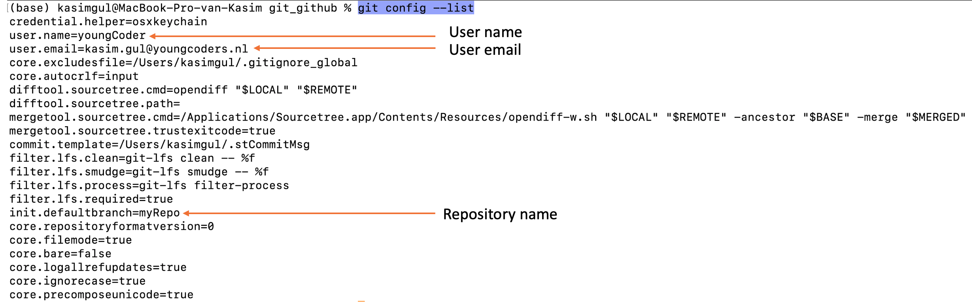

If you like, you can also get each individual information about your Git account such as username or email:

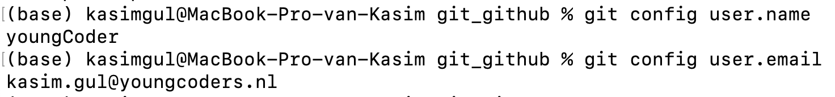

Git branching becomes very important when you work with other people on the same project. Let’s assume that your specific task on a project is to create the “login” part only. What you need to do is to isolate your work from other teammates work and manage your own repository. To do that you need to create your own branch. Let’s name our new branch as “login_task” by the following command line:

*$git branch login_task*

Git creates the new branch but will be still on the main branch. To change it to the new branch, use the following command:

*$git checkout login_task*

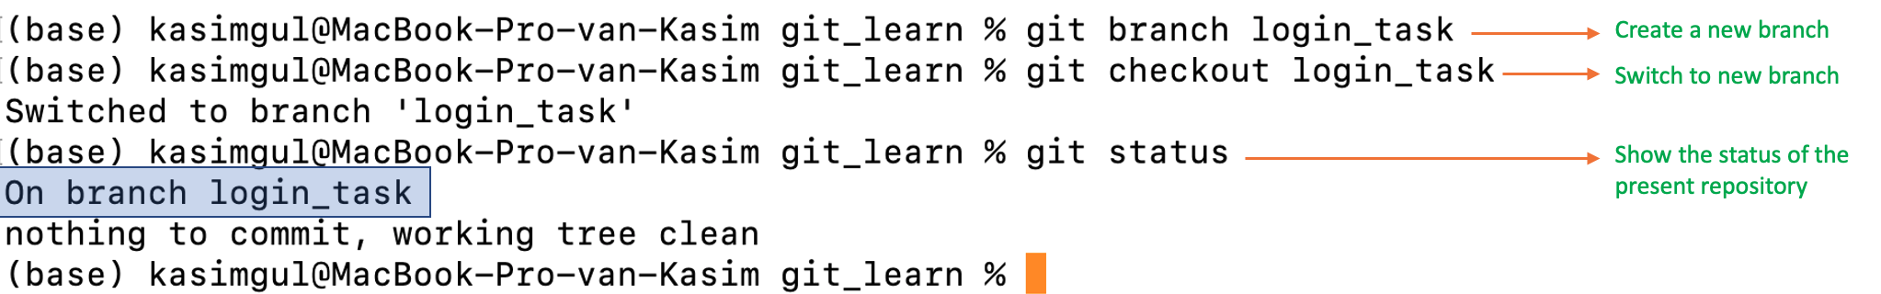

Now we are on the new branch “login_task”. I’ll create a new “login.html” file with the “touch” command and edit it with the Atom editor.

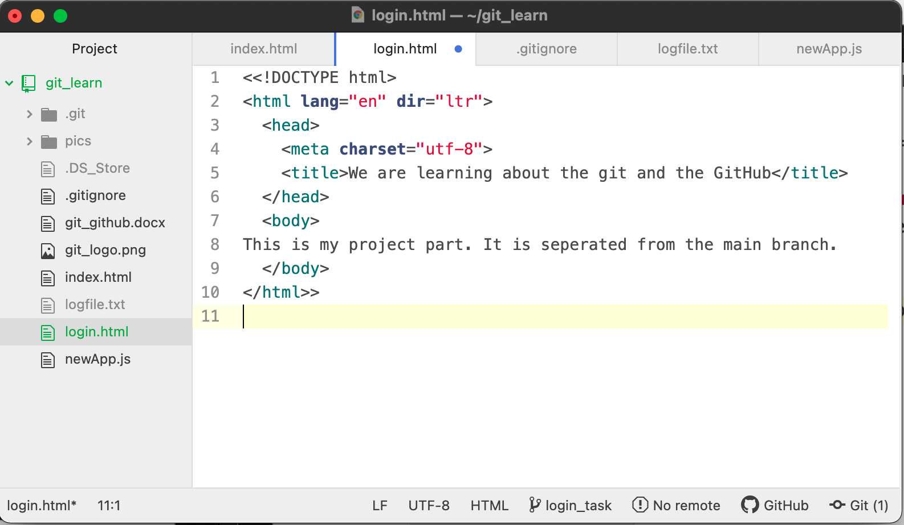

After editing the “login.html” file, we can do “git status” and see the status of the files and folders within this new branch. Only the “login.html” file will be listed. If we use the “git add” and then the “git commit” commands, “login.html” file will be moved into the staging area.

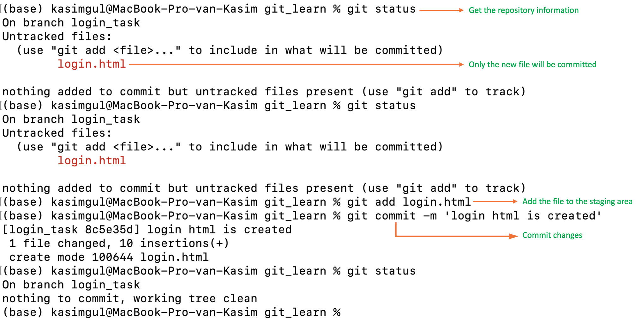

It is good to remember that we are still under the new “login_task” branch. Here is the list of all files and folders within our repository. I’ve highlighted the “login.html” file which we’ve created it while we are within the “login_task” branch. Keep that file in mind and let’s change our branch to the “main”.

*$git checkout main*

Now, let’s list all the files and folders within the same repository once more.

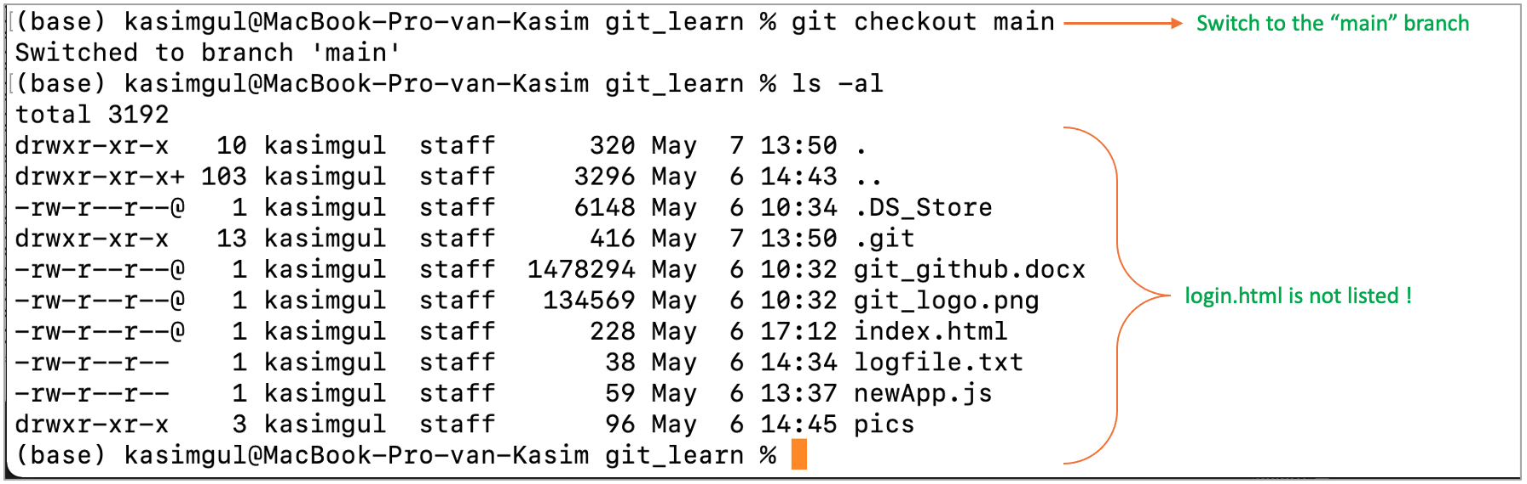

As you see that the “login.html” file is not listed. The reason is, we’ve created that file while we are in the “login_task” branch. If we switch back to the “login_task” branch and get the directory contents listed to confirm it.

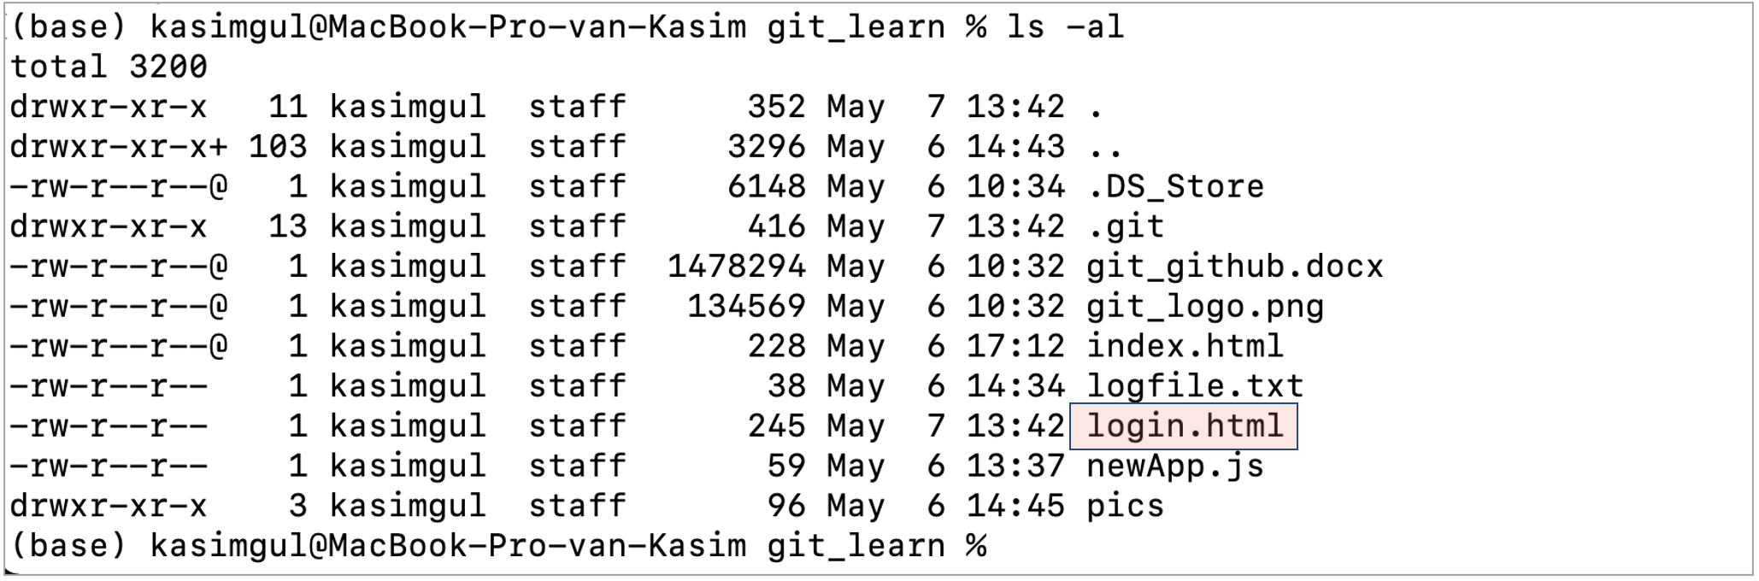

We see that the “login.html” file exists and visible under this branch. There is an additional command to “merge” them together which will be covered in the next command.

1. **git merge:** This command is used to integrate different branches into a single branch. The process of “merging” can be defined as a way of putting a “forked history” back together. The “git merge” command is used to integrate different branches into a single branch.

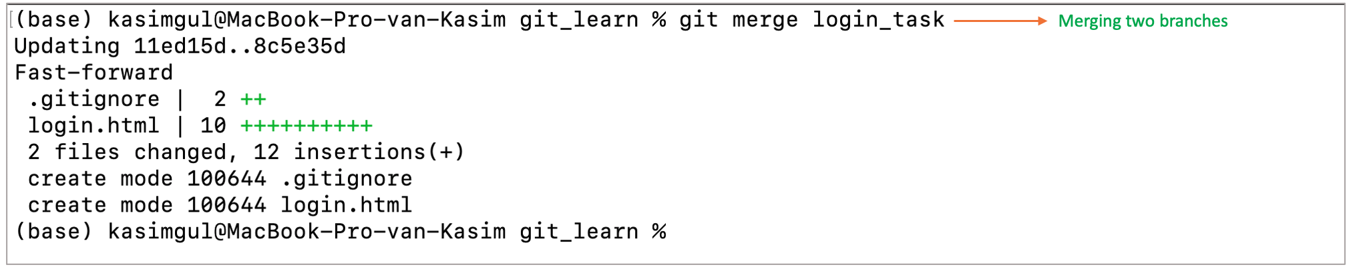

Now, we should be able to see the “login.html” file as listed even though we are in the “main” branch.

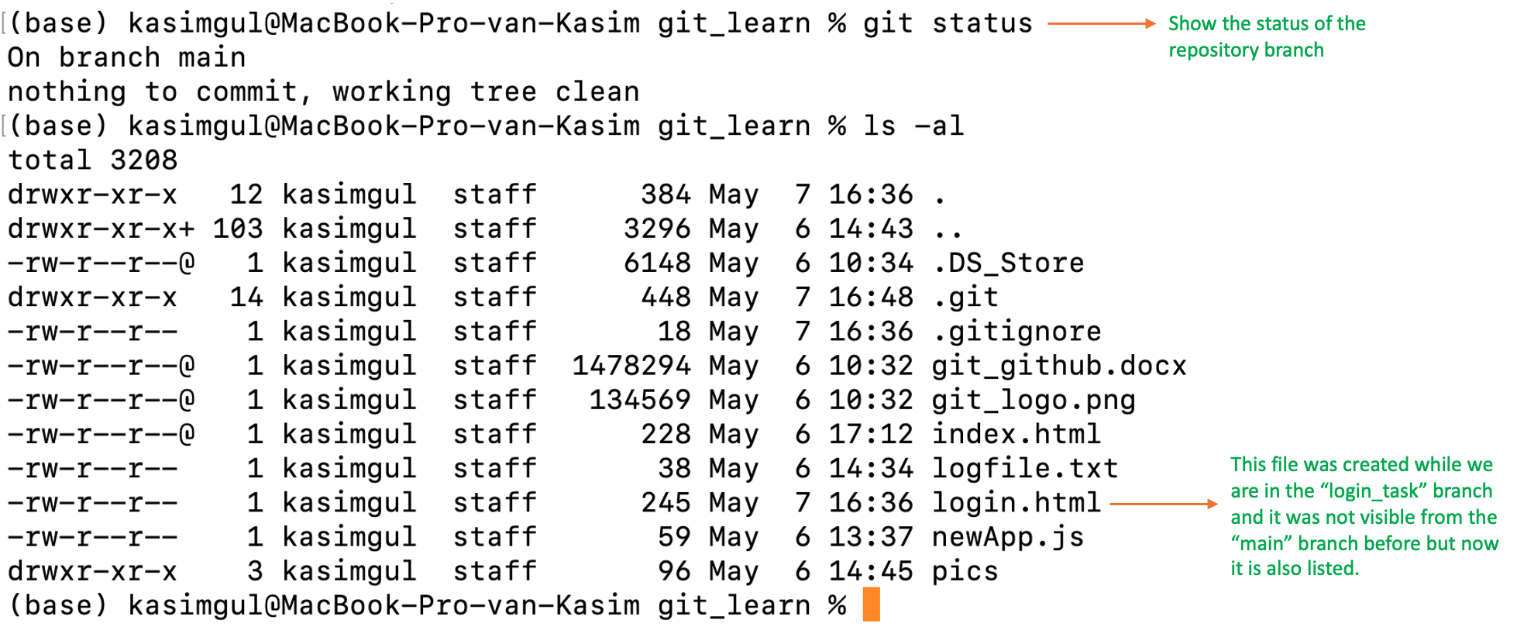

Here we can see that the “git merge” command lets you take the independent lines of development created by the git branch and integrate them into a single branch. This is simply how merging works between different branches.

So far, we’ve covered the commands that are related to manage the “local repository”. After now, we’ll learn how to use the commands for the “remote repository”. To be able to use those commands, we must have an account activated on GitHub. We’ll push and pull files between the local drive repository and the remote cloud repository. This is why we need to have access to the remote storage on GitHub. If you already have a GitHub account, you can use it. If you don’t have an account, then follow the instructions on the GitHub page and create an account.



I already have an account to use, so I’ll login to that account. There are good resources about the GitHub GUI interface. You can read it shortly and get familiar with the usage of it. We’ll directly dive in to creating a new repository. You can click on to “+” sign at the right top corner of the screen and then choose “New Repository”.

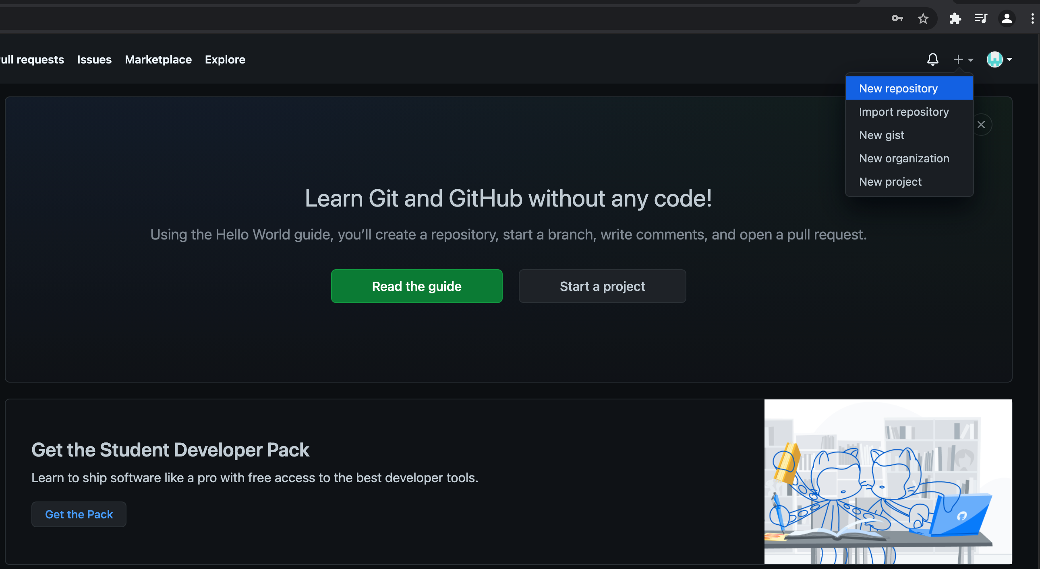

You have to choose a valid repository name and click on the button below to create the repository.

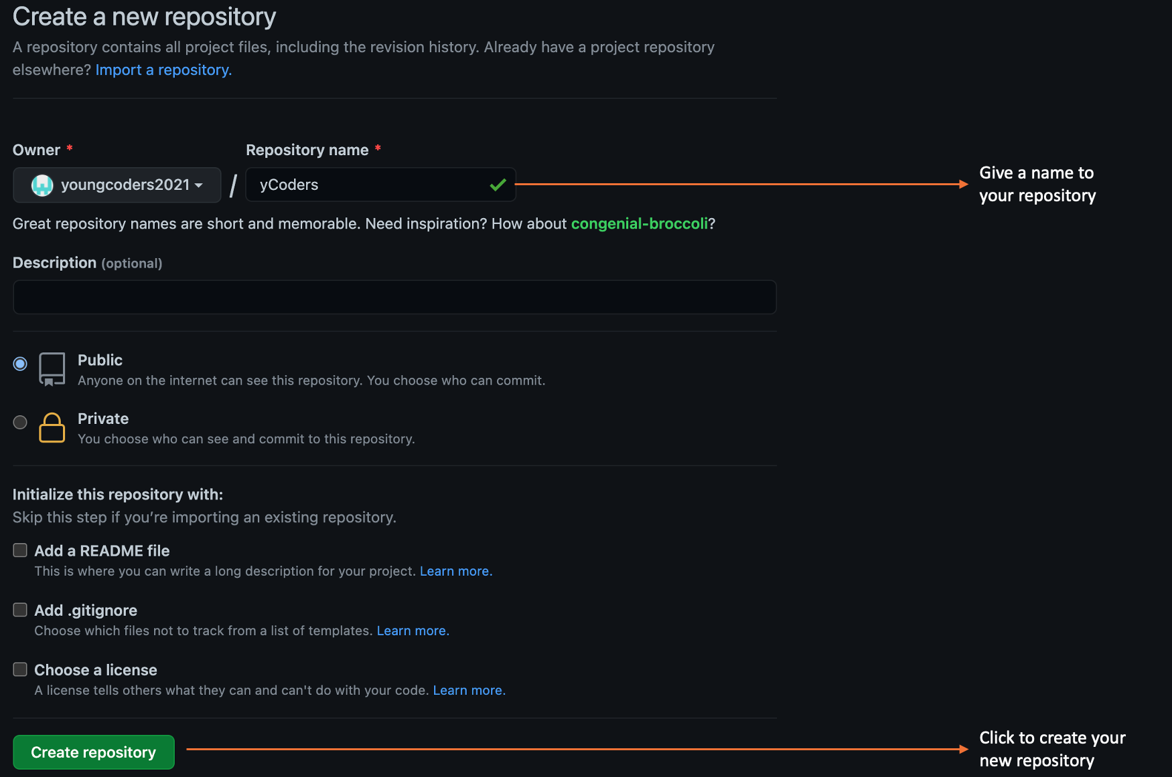

Once the new repository is created, you’ll see the following page with lots of descriptions about how to use the Git on the GitHub.

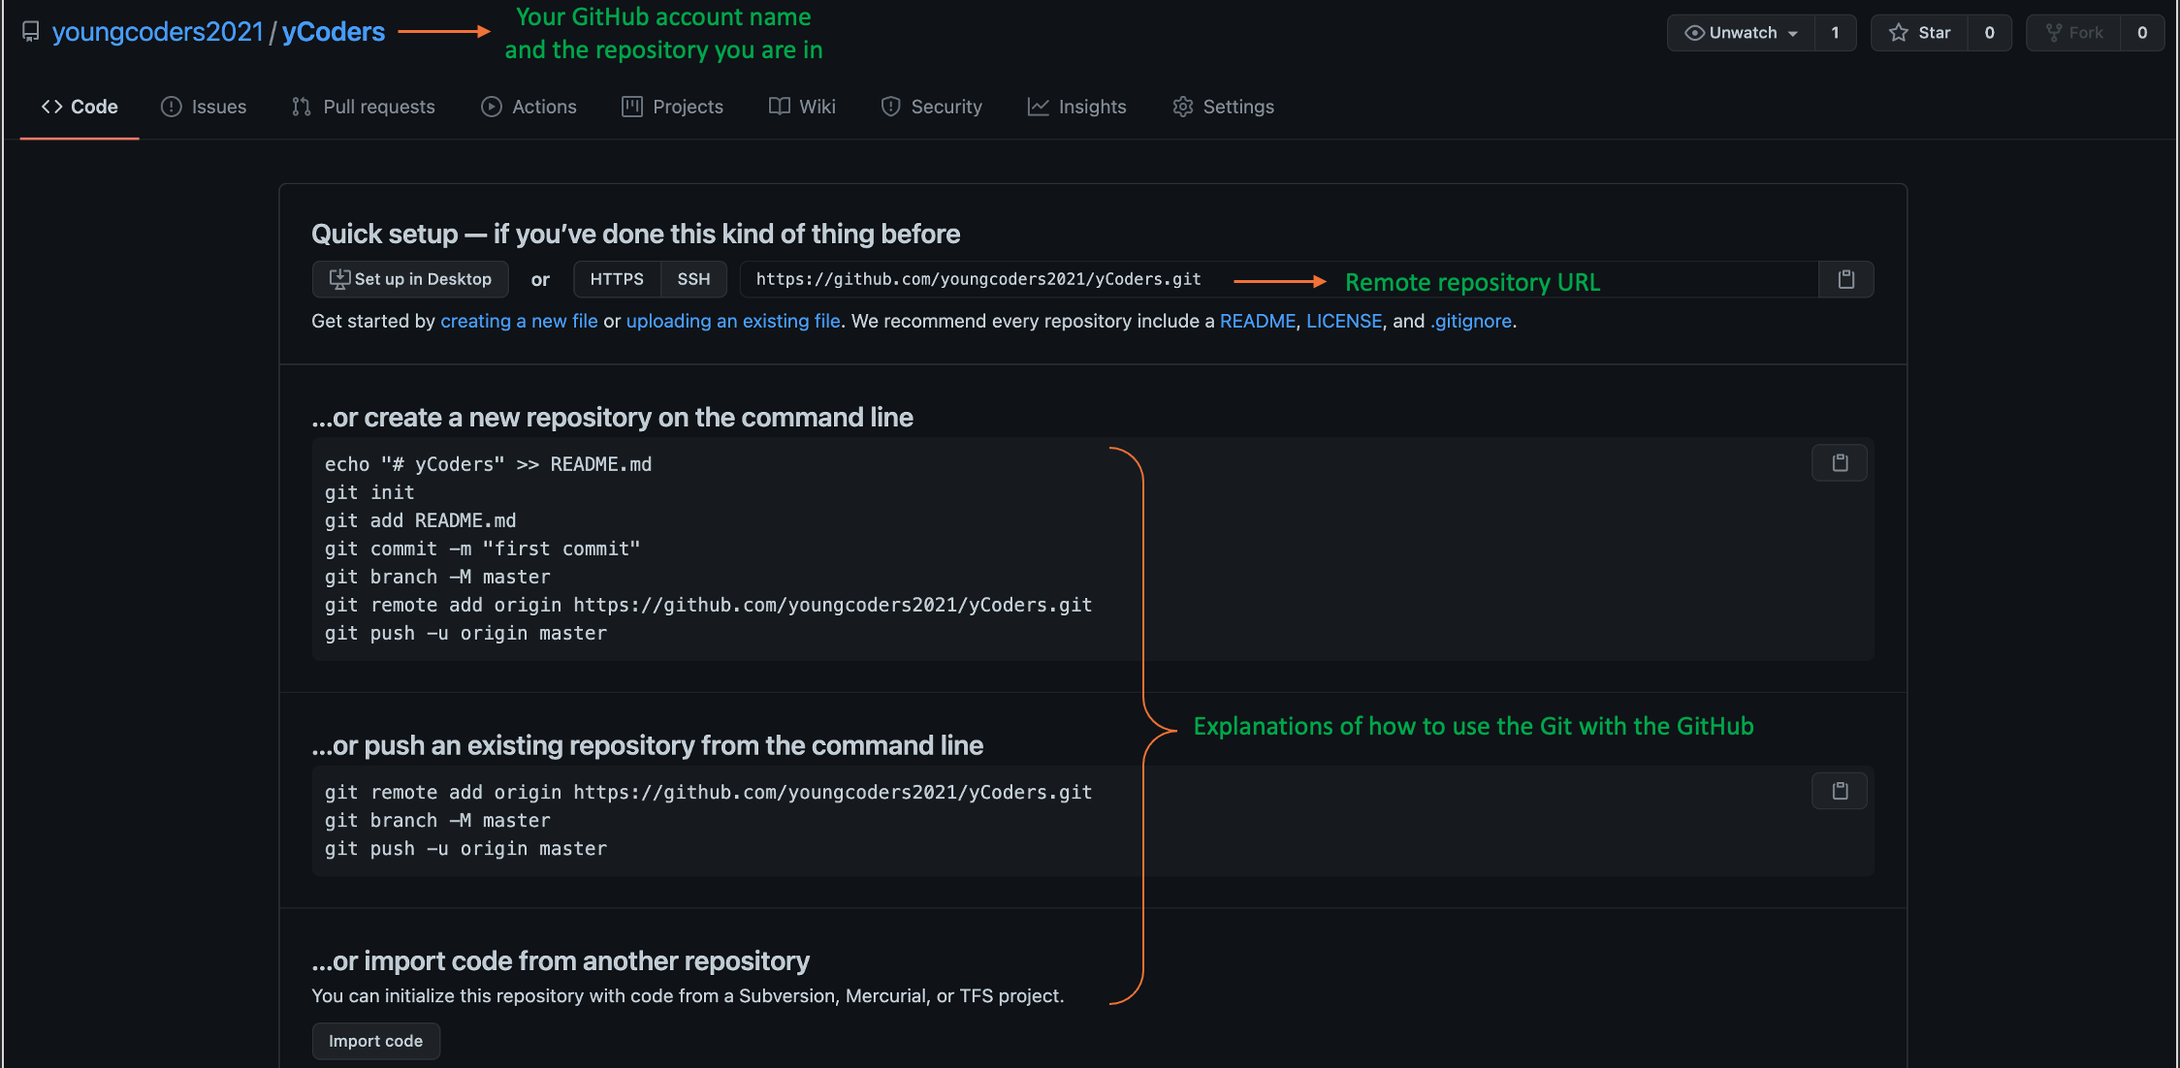

You might recognize some of those commands that are already explained such as “init”, “add” and “commit” commands. Now, we are ready to learn how to use Git commands for “remote” repository management. Pay attention to “Remote repository URL” which we’ll need with the following commands.

1. **git remote:** This command is used to add the “remote repository” which we’ve just created on GitHub to our Git repository settings. With no arguments, it shows a list of existing remote repositories. Several subcommands are available to perform operations on the remotes, but we’ll only see the most used of them. First, we should add the new remote repository we’ve created “yCoders”. Copy the URL address of this new repository and run the following command. Your repository name might be different than my remote repo name!

*$git remote add origin https://github.com/youngcoders2021/yCoders.git*



The next, will be pushing the local repository to the remote repository.

1. **git push:** This command is used to upload the content from the local repository to the remote repository. After a local repository has been modified, a “push” command is used to share the modifications with the remote team members with the following command line:

*$git push -u origin main*

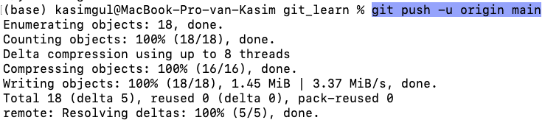

If the remote push is completed successfully, then we can go to our GitHub repository and see all the files being listed within the main branch. You may need to refresh your webpage to see the changes!

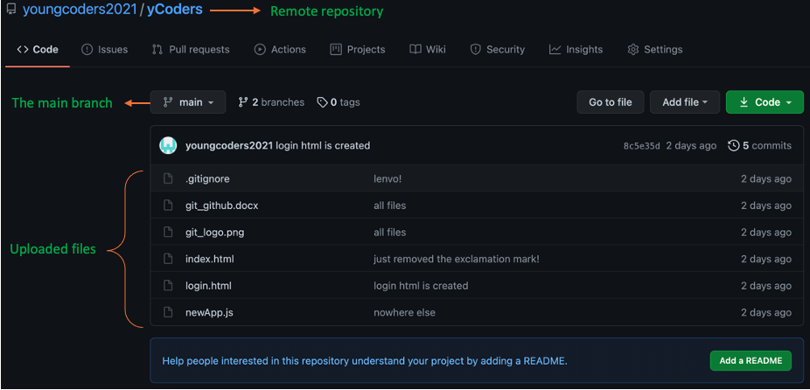

Ok, the local repository files are being pushed to the remote repository successfully.

Just to remind that the “logfile.txt” file and the “pics” folder are not pushed to the remote repository. You might be guessing the reason easily (.gitignore).

1. **git pull:** This command is used to fetch the new commits and merge them into the local branch. This command downloads content from the required remote repository. Let’s create the “README.md” file from the GitHub page. We can also manually upload a file to the GitHub which we’ll see it soon.

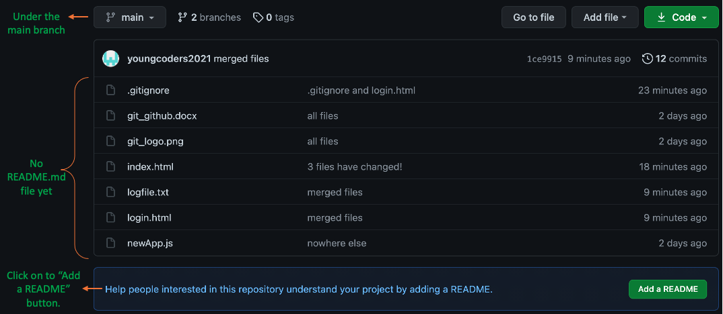

You can change the name if you want to, but since it is a standard way of using “README.md” I’ll leave as it is. This file type stands for “markdown” file formatting. Those lines that begin with “#” considered as “headings” also in different sizes.

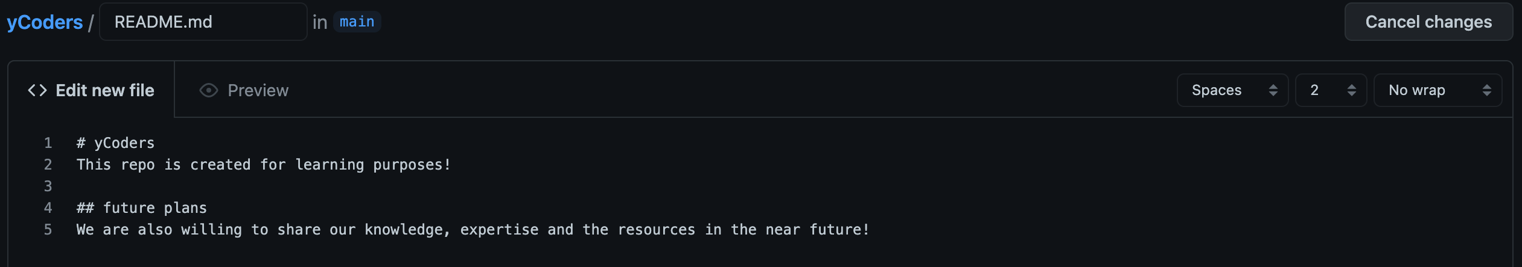

Add the bottom of the page there is only “Commit new file” button. We’ve already choose “Add” (command) when we’ve clicked the “Add README.md” button previously.

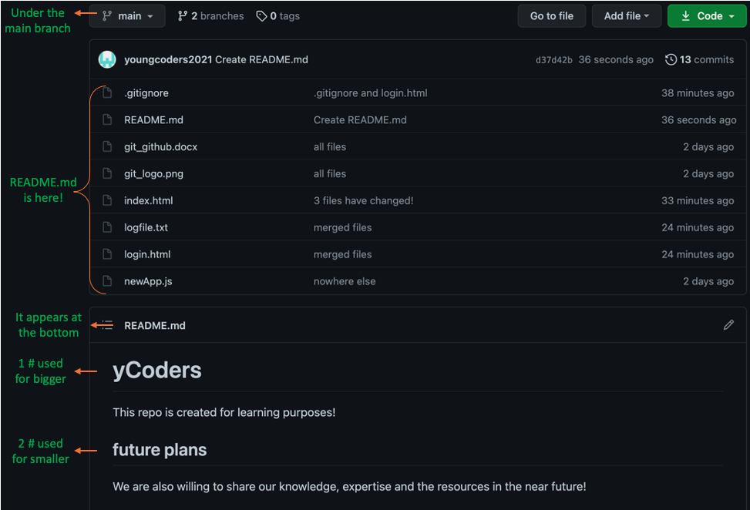

Well, we are ready to see the “git pull” command. At this state we have a new file under the “remote repository”. Let’s see if that is also exists within the local repository?

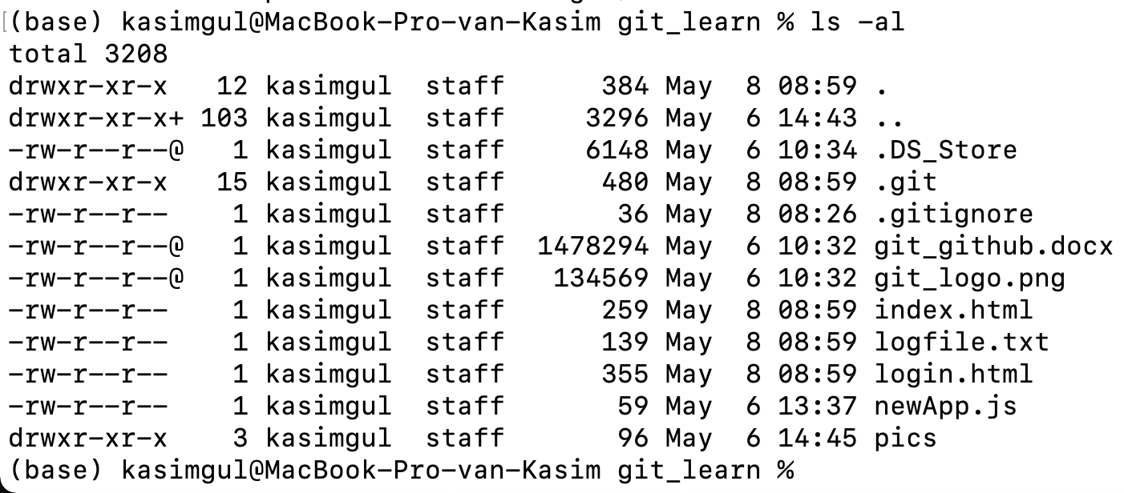

Looks like we don’t have it, yet! Now, we will use the “git pull” command to get the “added” and “committed” files to our “local repository”.

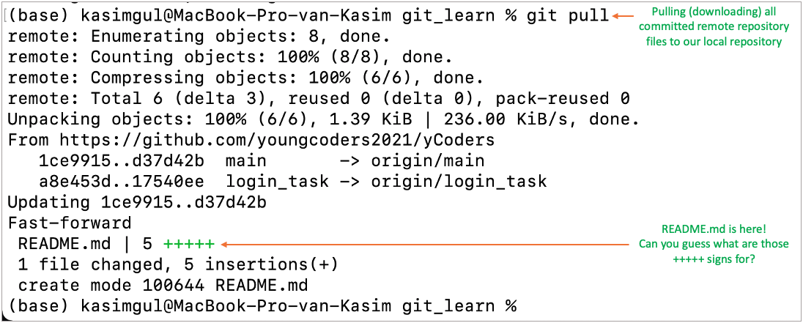

Good, its done well and we can list the files once more.

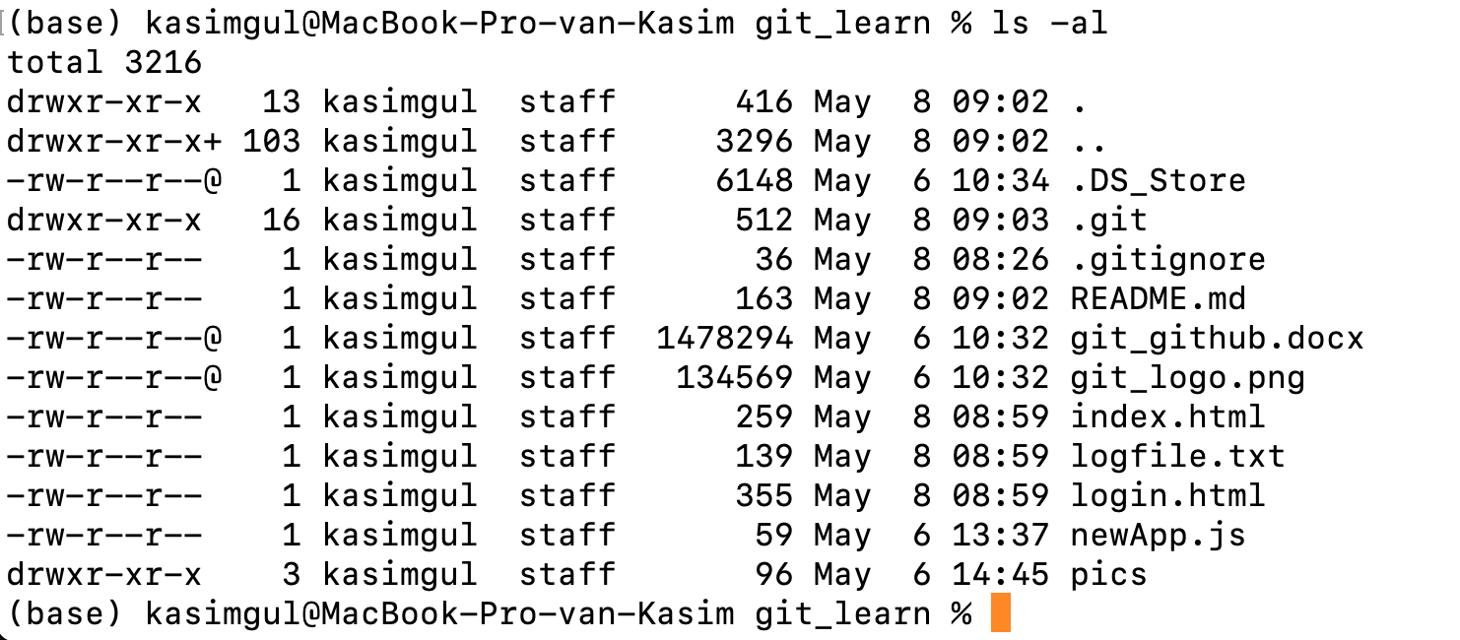

We can see that the “README.md” file is “pulled” to our “local repository”. Well, questions never end and here is a new one:

“What if we want to “pull” the complete “remote repository” to our local drive?” Coming next!

1. **git clone:** This command is used to create a copy of the target remote repository or create a “clone” in a new directory at a new place. We’ll use it for “pulling” the entire remote repository to our local drive. Let’s create another directory called “pull_repo”.

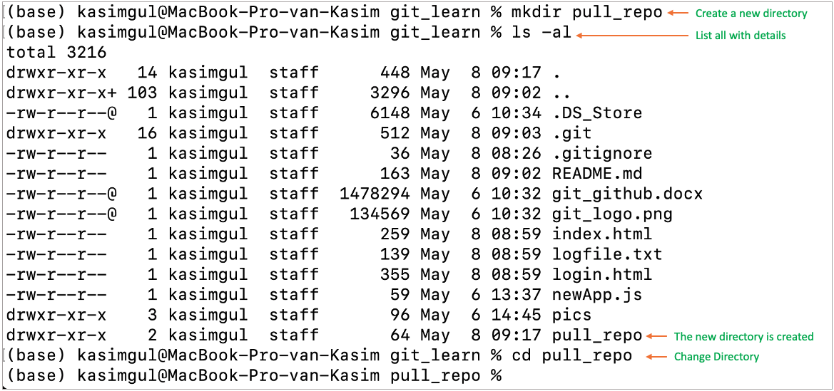

Now, we also need to have the remote repository link which we want to “clone” completely.

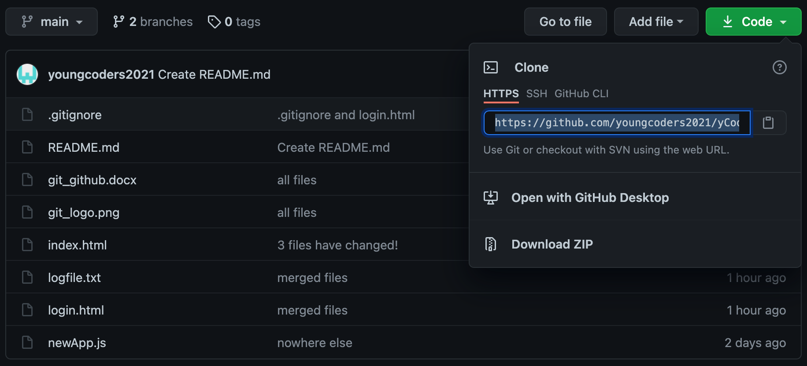

This is where we get the link of our remote repository. Next step is to execute the following command:

*$git clone https://github.com/youngcoders2021/yCoders.git*

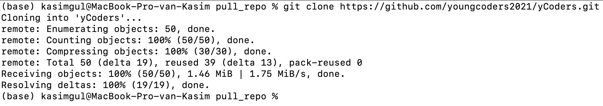

Depending on the size of the remote repository and of course your internet speed, “cloning” (downloading) time may change. Here we have small repository with few files to be cloned.

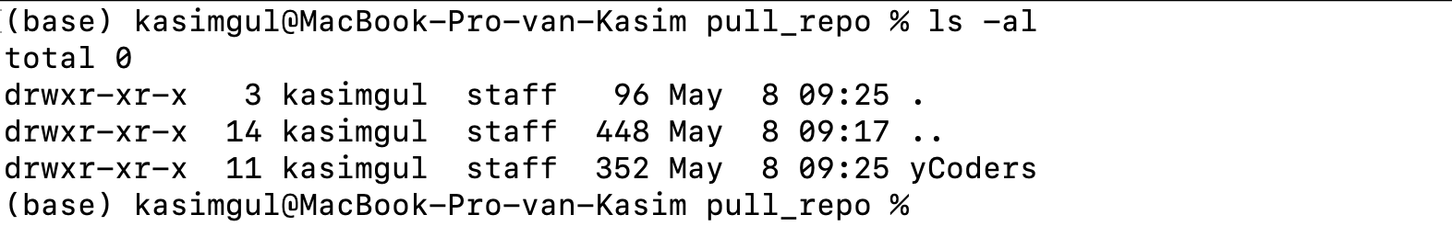

Listing will show us the “yCoders” folder which is also our “remote repository” name. We can go into the directory and compare the files and folders with the remote repository files and folders. Is it done well?

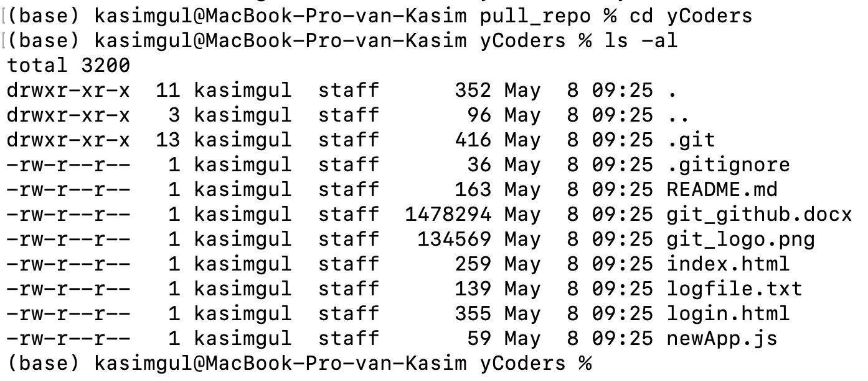

Yes, looks like it’s done well. This is how you can “clone” a remote repository if you have access to it. Remember, there are “private” and “public” types of GitHub repositories available. Sometimes, you might even have permission to access to some specific branches and also with specific permissions such as only reading or writing.

We can also do “git pull” while we are in the original “main” folder. That will update all local files from the remote repository. We should change the present directory back to our original local repository.

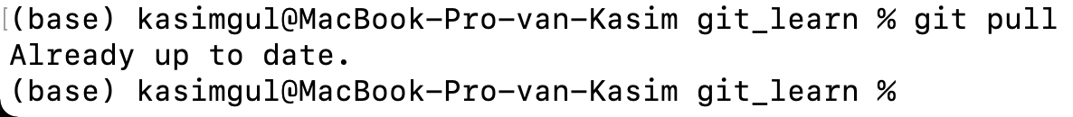

And here we have nothing to be “pulled”, because we don’t have any modification done at the “remote repository”. Let’s disturb (modify) the README.md file and try “git pull” command again.

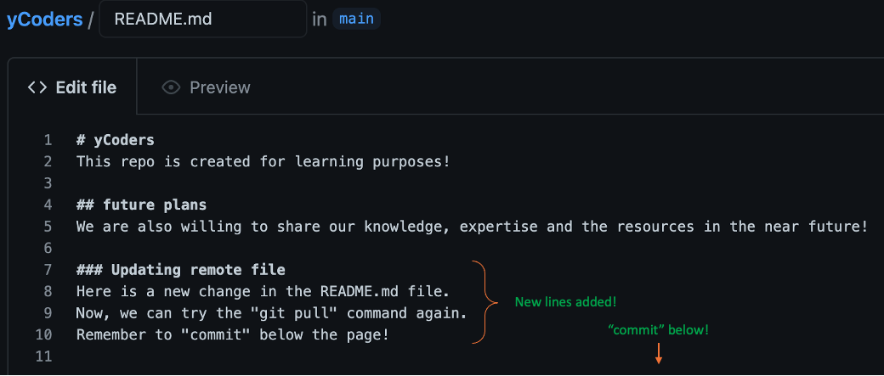

All right, after the remote editing is done, we are ready to try the “git pull” again.

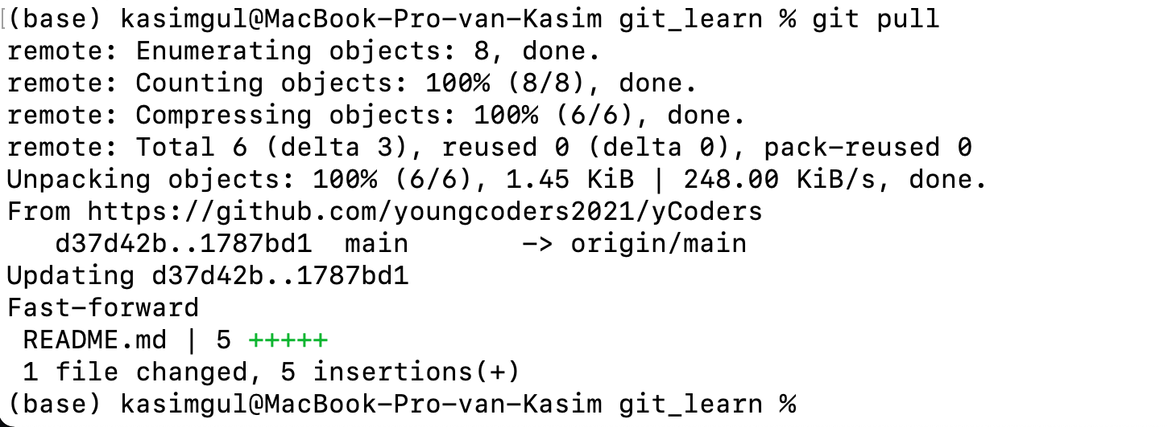

This time our “git pull” command worked, because there is a modified file, and it is “committed” to be “pulled”. We can check the local “README.md” file if the changes are updated.

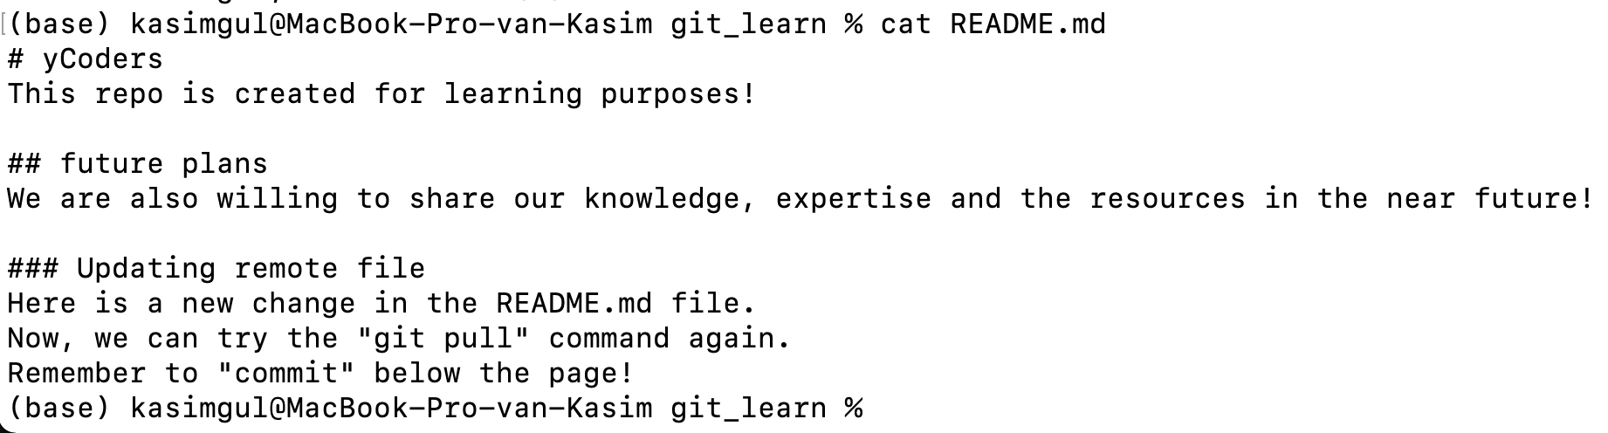

Of course the local “README.md” file is updated with the changes which are done on “remote repository”.

I think we’ve covered much enough how the Git and the GitHub works and what is their relation to each other. There are different remote repository providers such as Bitbucket or GitLab. They also work with very similar commands by some web account user interface differences. Always worth to try!